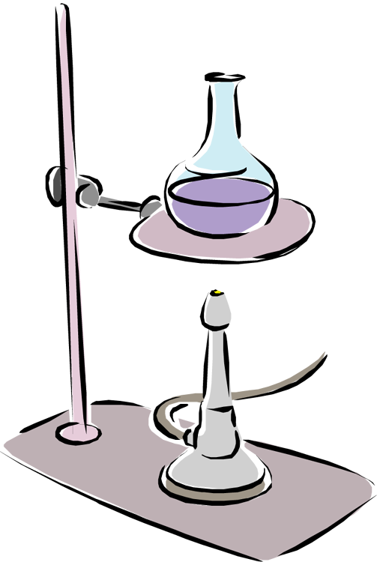
Name _______________________________

Date ____________
The Scientific Method:
Can You Write a Clear and Concise Lab Procedure?

Introduction: Once a problem has been observed and a hypothesis suggested, the next step in the scientific method is to design an experiment that will either prove or disprove the hypothesis. A key assumption is that the experiment will be repeated many times by other scientists. When scientists publish their work, they expect that it will be repeated and verified by other scientists in their field of study. In the publishing process, scientists must be able to write clear descriptions of the steps of their experiment so that others may be able to follow and repeat it.

Purpose: Can you write a procedure that can be repeated by your classmates?

Materials: Sets of building materials, notebook paper, pencil, screen

Procedure:
1. Each team of two students should have two sets of building materials. Place one set aside. Open the second set and remove the items.
2. Working with your partner, use the items from your bag to build a unique and unusual structure. You should do your building behind a screen so that other students cannot see your work.
3. Write a set of instructions that provide clear directions for how to build your structure. You must be exact and precise. As you are writing your instructions consider whether the instructions are clear enough for others to follow. Write your instructions in a stepwise fashion. For example:
Step 1. Place the red square on the table to provide a base.
Step 2. Take the blue triangle and……

4. Write your instructions for how to build your structure in the space below.

5. Once your directions have been completed, swap instructions with another team.
6. Read the directions from the other team and try to build their structure using your spare set of building materials.
7. When both teams have finished building, remove the screens. Compare the original structure to the replicated structure.

Analysis Questions:

1. Were your instructions written clearly enough for the other team to follow? ____________________________

2. How close was the other team in replicating your structure? ______________________________________________

____________________________________________________________________________________________________________________

3. Which part of your instructions were the most unclear or misleading? ___________________________________

____________________________________________________________________________________________________________________

____________________________________________________________________________________________________________________

4. Identify the step of your instructions that you feel was the most unclear and rewrite that step.

____________________________________________________________________________________________________________________

____________________________________________________________________________________________________________________

5. Why is it important that scientists write procedures that can be reproduced or replicated?

____________________________________________________________________________________________________________________

____________________________________________________________________________________________________________________

Copyright © November 2012 Amy Brown (aka Science Stuff)
Tips and Strategies:

1. The sets of building materials can be almost anything that can be connected or stacked into unique structures. Here are some possible ideas:
- Blocks from a Jenga game.
- Legos
- Tinker toys
- Lincoln Logs
- A molecular model set
- You can make a set of building materials by choosing from a variety of household items: toothpicks, pieces of cardboard, gum drops, marshmallows, Styrofoam cut into various shapes, etc.

2. Put the building materials into a zip lock bag. The number of items in the bag should be determined by the age level and ability level of the student completing the activity. For younger students, place fewer items in the bag. Make the activity more challenging for older students by placing more items of greater variety in the zip lock bag.

3. A screen or shield must be set up to prevent one team from seeing the structure built by another team. I have used legal size manila folders and sheets of cardboard for this.

4. Student answers will vary on questions 1 – 4.

The answer to question 5: Writing procedures that are clear and accurate will allow other scientists to repeat the experiment and to verify the results.

5. This activity can be repeated several times throughout the year. I find that after completing several labs in my class, students begin to recognize how to write the steps of a procedure more accurately and more clearly. If I have the time to repeat the activity, I try to assemble bags of building materials that are more challenging.

6. If your students participate in science fairs, this activity is wonderful at helping the students learn how to write out the steps of their experiment.

Created by Amy Brown – Science Stuff
Copyright © November 2012 Amy Brown (aka Science Stuff)
All rights reserved by author.
This document is for your classroom use only.
This document may not be electronically distributed or posted to a web site.

