Name:
Reproductive System Labeling

Directions: use page 1012 in the text to help you label the diagram. Label the following: 2,3,7,8,12,13,14,18
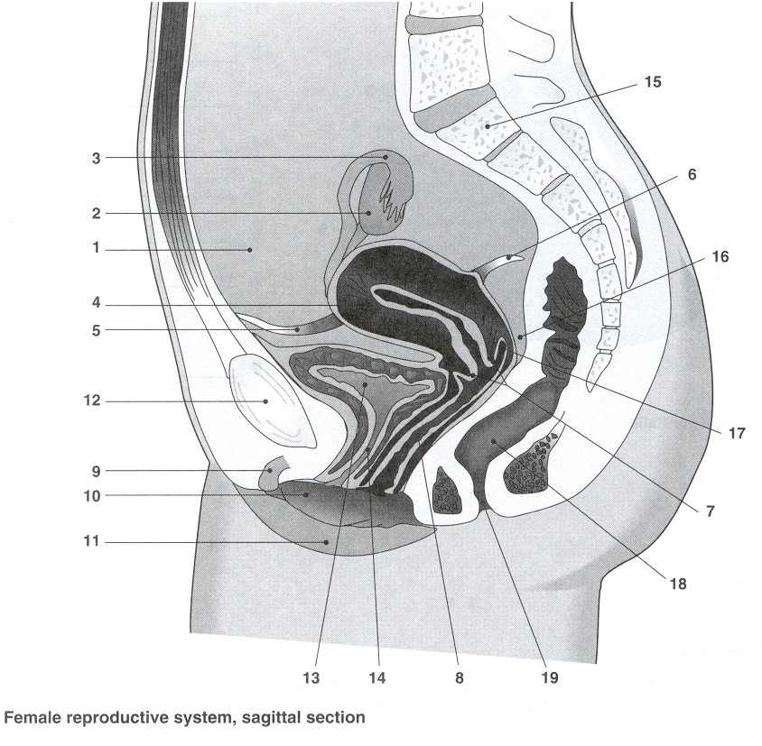

Directions: use page 1010 in the text to help you label the diagram. Label the following: 1,2,3,4,6,8,10,11,17,19
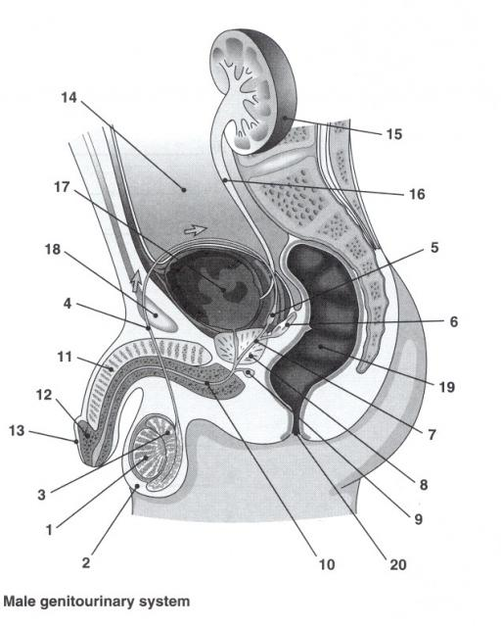

Use pages 1010-1013 and/or the glossary to help you to give a function for each part of the reproductive system.

Cervix: ________________________________________________________________________________________________________________________________________________________

Ovary:
________________________________________________________________________________________________________________________________________________________

Fallopian tube:
________________________________________________________________________________________________________________________________________________________

Bladder:
________________________________________________________________________________________________________________________________________________________

Urethra:
________________________________________________________________________________________________________________________________________________________

Vagina:
________________________________________________________________________________________________________________________________________________________

Rectum:
________________________________________________________________________________________________________________________________________________________

Vas deferens:
________________________________________________________________________________________________________________________________________________________

Penis:
________________________________________________________________________________________________________________________________________________________

Seminal vesicles:
________________________________________________________________________________________________________________________________________________________

Prostate gland:
________________________________________________________________________________________________________________________________________________________

Epididymis:
________________________________________________________________________________________________________________________________________________________

Testes:
________________________________________________________________________________________________________________________________________________________

Scrotum:
________________________________________________________________________________________________________________________________________________________

