Introduction:
Charles Darwin accumulated a tremendous collection of facts to support the theory of evolution by natural selection. One of his difficulties in demonstrating the theory, however, was the lack of an example of evolution over a short period of time, which could be observed as it was taking place in nature. Although Darwin was unaware of it, remarkable examples of evolution, which might have helped to persuade people of his theory, were in the countryside of his native England. One such example is the evolution of the peppered moth Biston betularia.
The economic changes known as the industrial revolution began in the middle of the eighteenth century. Since then, tons of soot have been deposited on the country side around industrial areas. The soot discolored and generally darkened the surfaces of trees and rocks. In 1848, a dark-colored moth was first recorded. Today, in some areas, 90% or more of the-peppered moths are dark in color. More than 70 species of moth in England have undergone a change from light to dark. Similar observations have been made in other industrial nations, including the United States.

Instructions:
As a class we will complete the simulations at http://askabiologist.asu.edu/activities/peppered-moth . We will use the data collected to fill out the table below.
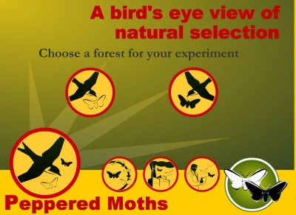

Forest | Trial 1: % light | Trial 1: % dark | Trial 2: % light | Trial 2: % dark | Trial 3: % light | Trial 3: % dark | Trial 4: % light | Trial 4: % dark
Light
Dark

Light Forest
Average % of light moths: ____________
Average % of dark moths: ____________

Dark Forest:
Average % of light moths: ____________
Average % of dark moths: ____________

Final Analysis
1. Explain how the color of the moths increases or decreases their chances of survival.

2. Explain the concept of "natural selection" using your moths as an example.

3. What would happen if there were no predators in the forest? Would the colors of the moths change over time? Defend your answer?

