Scientific Method Flow Chart
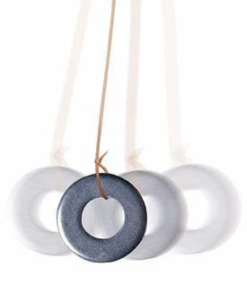
This chart can be used with almost any experiment you can think of. Use it to help organize a lab or design a science project.

Pendulum Lab - Student Guide

Project Goals :
- To design and conduct an experiment to determine how the length of a string and how the weight affect the number of swings of the pendulum.
- To understand how to isolate and manipulate variables
- To demonstrate an ability to organize and interpret data
Materials: String, masking tape, timers, washers or paper clips to serve as weights.

Project Guidelines
The instructions are left vague because it is up to you and your group to determine a hypothesis, design a test for the hypothesis and present your findings in a lab report.
Some questions to consider with your lab partner before you get started:
1. You are working with two variables (length and weight), do you want to have a separate hypothesis for each variable?
2. How will you write your hypothesis, traditionally it is written as an if-then statement. Two statements with two separate tests are acceptable, just be clear in how you write it.
3. How will you measure the number of swings? 60 seconds, 30 seconds?
4. How will you make sure each test is the same? Will you always drop the pendulum in the same way? How will you secure the pendulum? Why is holding the pendulum in your hand not a good idea?

Lab Report
You will prepare a lab report individually. Be sure that each member of the group has a copy of the data, reports will share data, but conclusions and writing are individual. Use the flow chart included with this worksheet. Your report should include:
1. Description of the problem, hypothesis
2. Procedure (explains how you will test it, pictures can be used)
3. Data table
4. Conclusions - Make sure you use your data to answer the question. Remember you have two variables in the experiement - length and weight. Both may have differing affects on the number of swings. Its up to you to find out exactly how each variable changes the pendulum's period (swings per minute)
5. Use the flow chart to check that you have all parts of the lab report included.

