GENETICS: PART 2

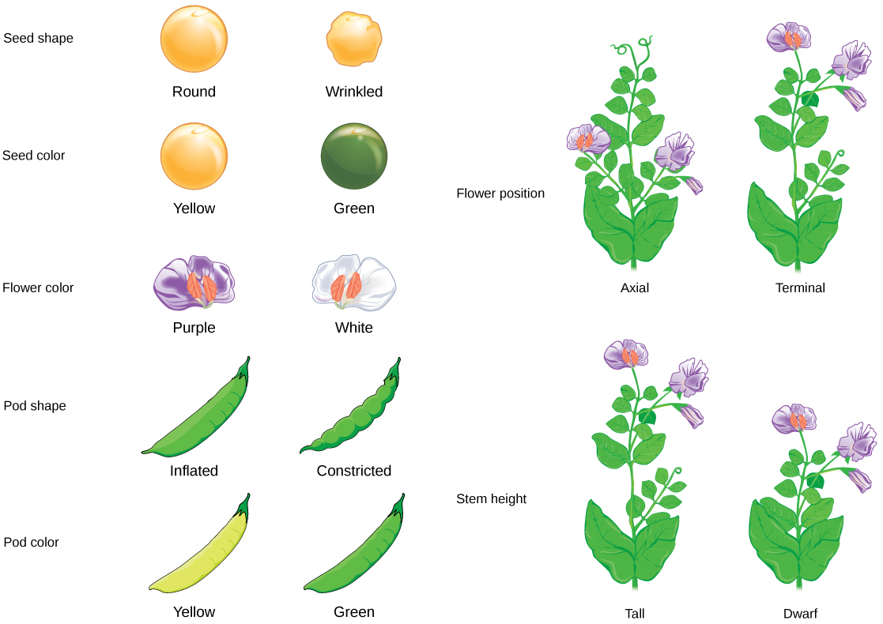

NAME:_________________________________________

Big Question: How are traits determined in sexual reproduction?

LT: ___________________________________
_______________________________________

A brief review:

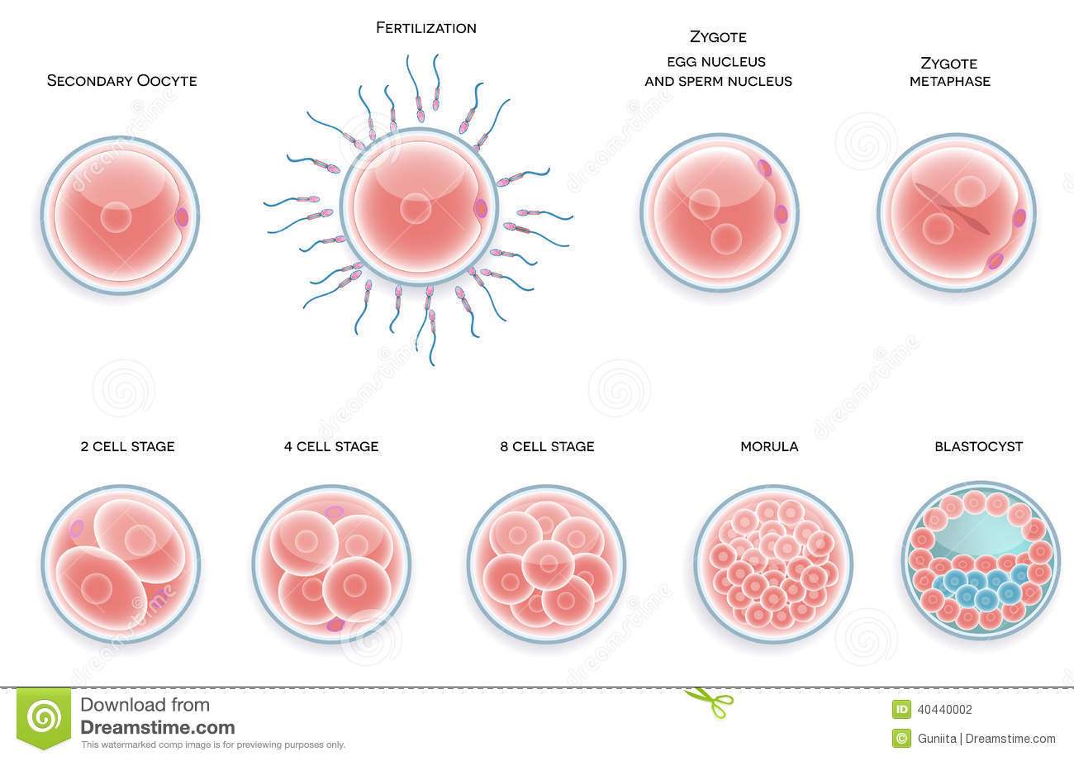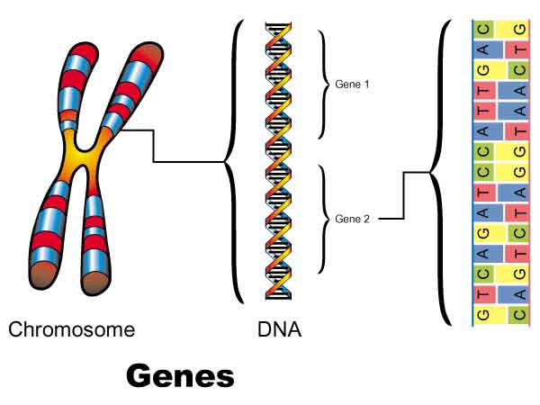

What do you remember about:

Egg cells | Sperm cells | Chromosome  Numbers | Fertilization | Cell reproduction

Question:
Human mom has brown eyes. Human dad has blue eyes.
Baby has brown eyes.

Human mom has blue eyes and Dad has brown eyes. Baby has blue eyes.

Why does the baby only show the brown eyed trait?

Possible answers:

KEY IDEAS:

- When sperm and egg cells are created, they only
Receive ½ the possible chromosomes.
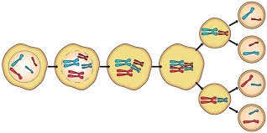
- You, for example, have two genes for eye color.
One of those genes you inherited from mom, the other from dad.

- When/If YOU have a child, you can only pass on ONE of your genes for eye color, NOT both.

DOMINANT GENES:

RECESSIVE GENES:

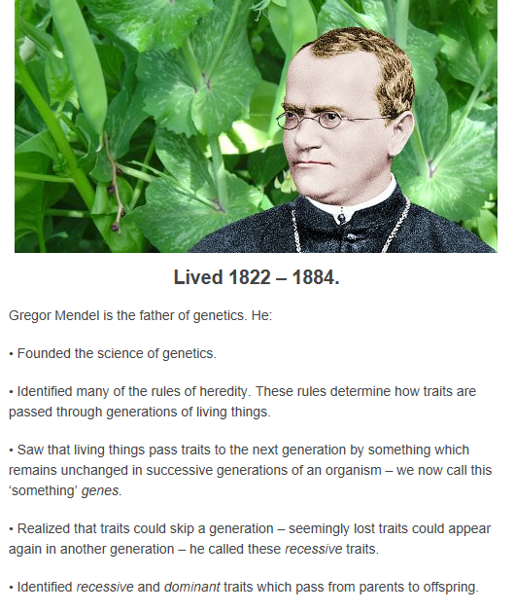
In his experiments, Mendel studied the traits of pea plants.
Since flowers are for SEXUAL REPRODUCTION, he could pollinate the flowers of different plants.
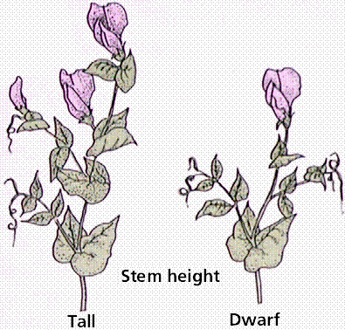

For example, he cross pollinated tall pea plants with dwarf pea plants. The plants produced seeds, which were the offspring. Mendel planted the seeds to see how the offspring would grow.

PREDICTIONS:

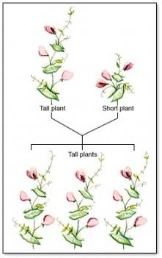

Ok, Mendel’s new question was “Was the short trait still there?” So, here’s another experiment. He took the HYBRID tall plants and cross pollinated them.

PREDICTIONS?:

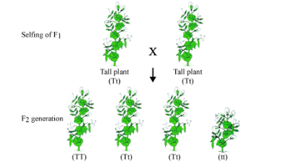

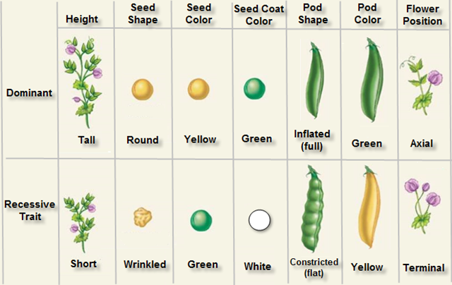

Understanding Dominant and Recessive Genes With Pictures
RULE

How to represent dominant and recessive genes with letters:

Practice : Human genetics faces

Traits:
Dimples (D) Freckles (F) Tongue roll(R)

Widow Peak(P) Loose earlobes (L)

Child 1  DD  FF  RR  PP  LL | Child 2  Dd  Ff  Rr  Pp  Ll
Child 3  dd  ff  rr  pp  ll | Child 4  dD  ff  Rr  Pp  ll

Learning Target:

Sponge:

Sponge:

Sponge:

Punnett Squares:

Definition:

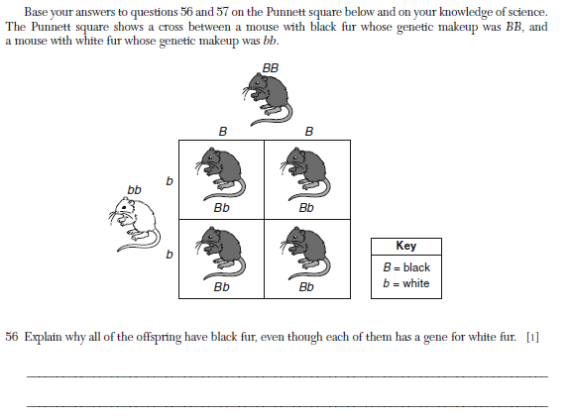

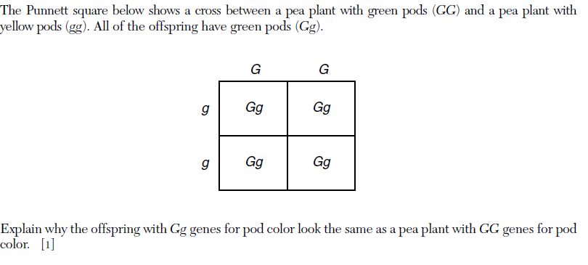

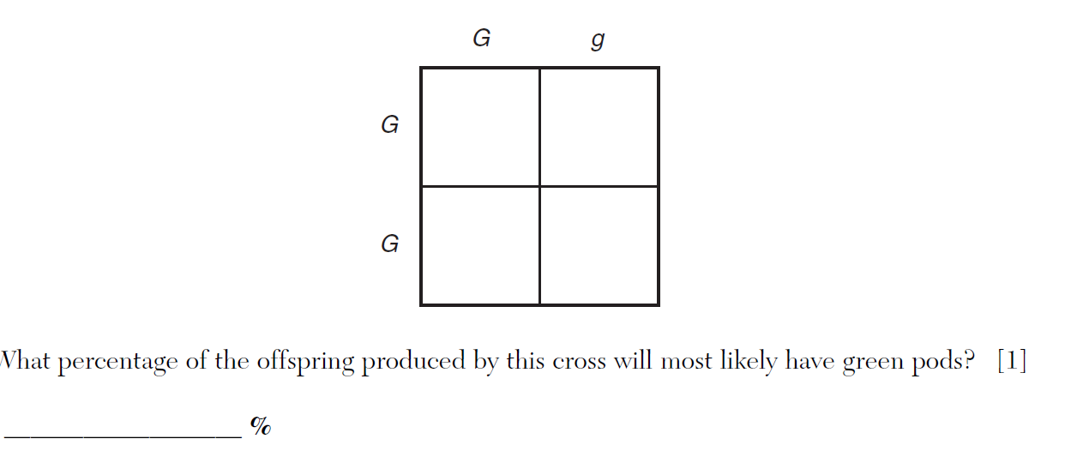

Example:
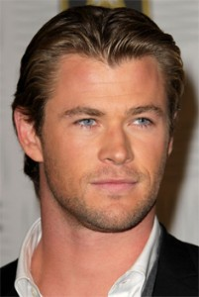
W = Widow Peak w = Straight hairline

Parent 1: Ww Parent 2: ww

Create a Punnett square to predict the offspring:

What is the percent probability of a child having a widow peak?

Answer:________%

Example: Hitchhiker’s Thumb
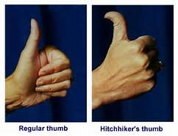
H= Regular thumb h=Hitchhiker’s thumb
Parent 1: Hh Parent 2 : Hh

- Create a Punnett square to show the possible offspring.

- What is the percent probability of having offspring show the dominant trait? Answer ___________

- What is the percent probability of having the offspring show the recessive trait? Answer: ____________

Example: Tongue Rolling
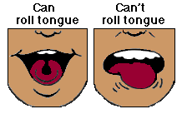

Parent 1: rR Parent 2: RR

- Create a Punnett square to show the offspring of these two parents?

- What is the probability of a child who can roll their tongue?
Answer: _______________

- What is the percent probability of having a child who carries a recessive gene?
Answer: ___________

