STEM Science Notebook
Diversity of Life
Investigation 7
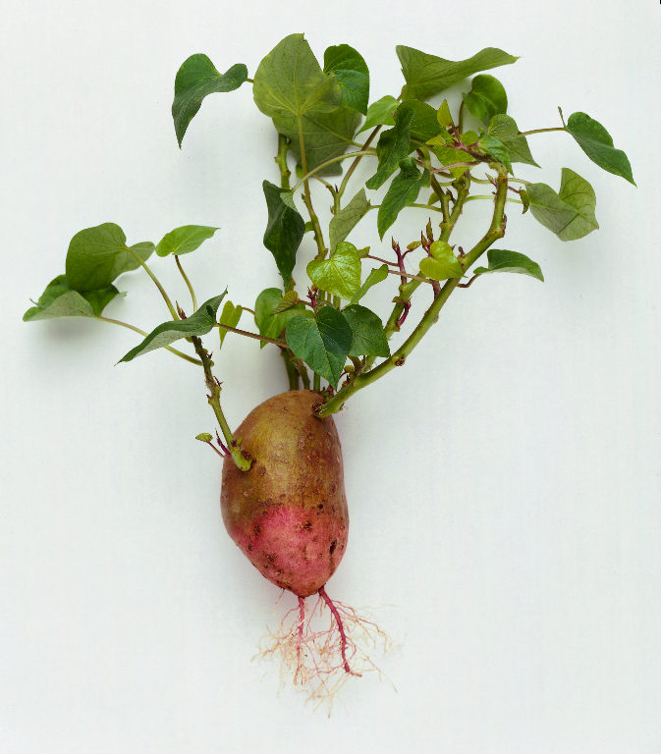
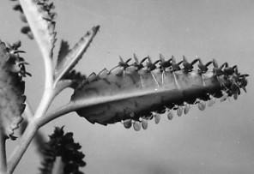

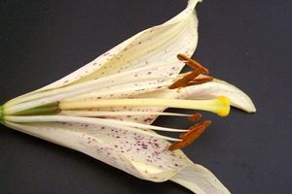

BIG QUESTION: How do plant structures function to promote reproduction and survival of the next generation of plants?
Sorting Activities 1 & 2
What I Notice:

Explanation:
__________________________________________
__________________________________________
__________________________________________
__________________________________________
__________________________________________
__________________________________________
__________________________________________
__________________________________________
__________________________________________

What Do You Think?
Why are there different ways to reproduce?

Focus Question 1: Why is there variation in the ways organisms reproduce?
Organism 1 Organism 2
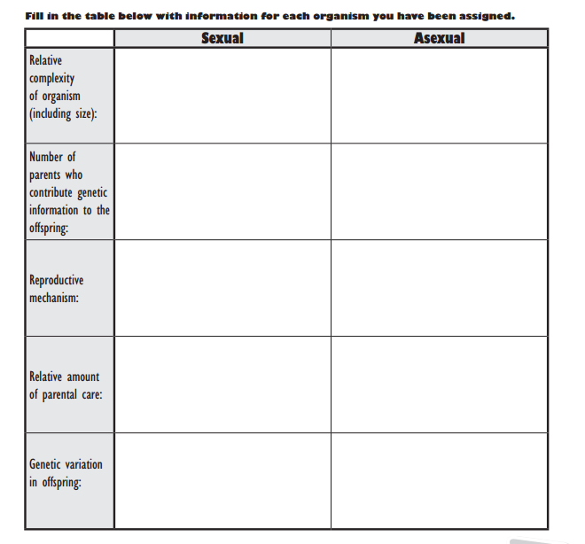
_______________________ _______________________
Characteristic of Sexual Reproduction | Characteristic of Asexual Reproduction
Explanation:
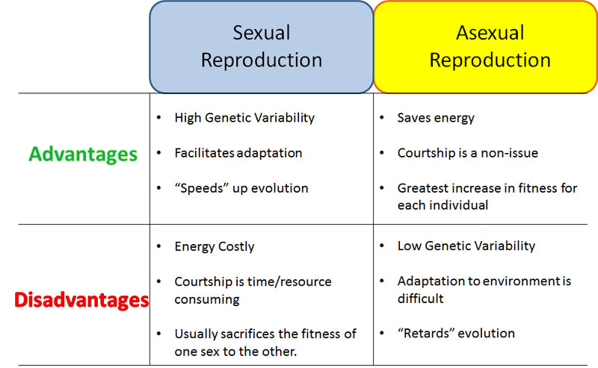

Explanation, Cont.:
__________________________________________
__________________________________________
__________________________________________
__________________________________________
__________________________________________
__________________________________________
__________________________________________
__________________________________________
__________________________________________
__________________________________________
__________________________________________
__________________________________________
What Do You Think Now?
Why are there different ways to reproduce?

Focus Question 2: What structures are required for sexual reproduction in plants?
Reading “ Flowers: More than Just Pretty”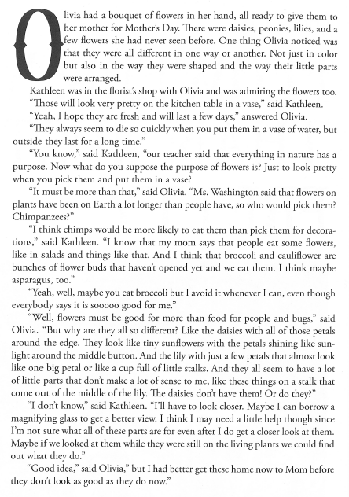
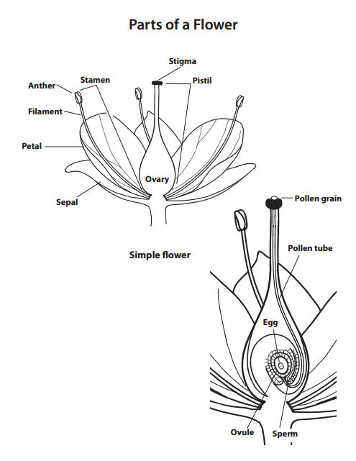
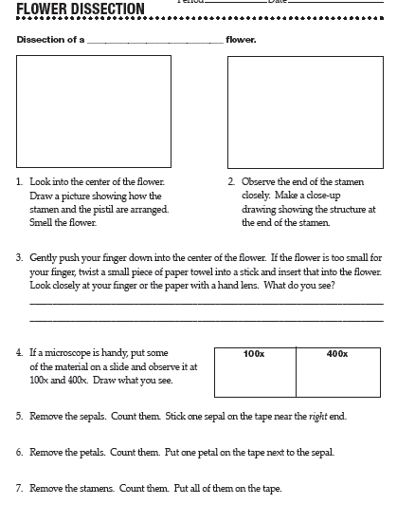
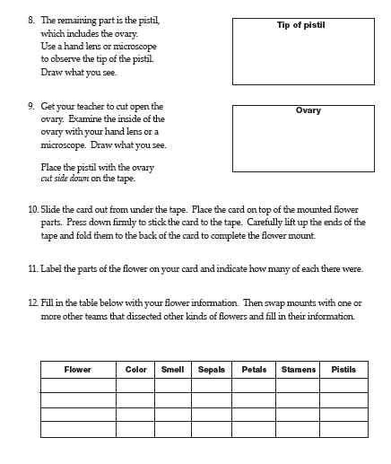
After reading the flower information resource page, add any information you can to the chart above.
Focus Question 3: How do the required structures of flowers contribute to plant reproduction?
Pollination Story Strips

Number Sequence: ______,______,

______,______,______,______,

______,______,______,______,

Reading “Flowers to Seeds” p. 40-45
- Many plants can be pollinated only by pollen from other plants of the same kind. How does pollen get from one plant to another?
______________________________________________________________________________________________________________________________
- What is a pollinator and how might one be attracted to a plant?
______________________________________________________________________________________________________________________________
- Why is pollination necessary?
______________________________________________________________________________________________________________________________
- Describe how seeds develop as a result of sexual reproduction after pollination.
_____________________________________________________________________________________________________________________________________________________________________________________________
- What is fruit? Give some examples other than those mentioned in the reading.
______________________________________________________________________________________________________________________________
- Explain why bees pollinate flowers.
_______________________________________________________________

_______________________________________________________________

What structures are required for reproduction?

How do the structures themselves encourage reproduction?

Focus Question 4: What factors affect the reproduction process of a plant and what can a plant do to ensure the survival of the next generation?
Reading “Seeds on the Move” p. 46-50
Word Bank
______________________  ______________________  ______________________  ______________________  ______________________  ______________________  ______________________  ______________________  ______________________  ______________________  ______________________ | ______________________  ______________________  ______________________  ______________________  ______________________  ______________________  ______________________  ______________________  ______________________  ______________________  ______________________
______________________  ______________________  ______________________  ______________________  ______________________  ______________________  ______________________  ______________________  ______________________  ______________________  ______________________  ___________________ | ______________________  ______________________  ______________________  ______________________  ______________________  ______________________  ______________________  ______________________  ______________________  ______________________  ______________________  ____________________
Content
__________________________________________

__________________________________________

__________________________________________

__________________________________________

__________________________________________

__________________________________________

__________________________________________

__________________________________________

__________________________________________

__________________________________________

__________________________________________

__________________________________________

__________________________________________

__________________________________________

__________________________________________

__________________________________________

__________________________________________

__________________________________________

__________________________________________

__________________________________________

__________________________________________

__________________________________________

Question | How do plant structures function to promote reproduction and survival of the next generation of plants?
Claim
Evidence

Analysis
 | Claim  A statement or conclusion that answers the original question/problem. | Evidence  Sufficient and appropriate scientific data/information and/or personal information or experiences that supports the claim. |  | Analysis  A justification that connects the evidence to the claim by using appropriate and sufficient scientific principles and vocabulary.
0 | Does not make a claim, or makes an inaccurate claim. | Does not provide evidence, or only provides inaccurate evidence or vague evidence (i.e. the data shows me it is true) |  | Does not provide an analysis, or only provides an irrelevant analysis.
1 | Makes an accurate claim but vague or incomplete claim. | Makes a general statement and does not include specific data. |  | Repeats evidence and links it to the claim, but does not include scientific principles and/or vocabulary
2 | Makes an accurate and complete claim. | Provides 1 piece of evidence to support their claim |  | Connects evidence to the claim using scientific principles or vocabulary but not both.
3 | Claim is exceptionally well done and able to be understood minus the question | Provides 2 or more pieces of evidence to support their claim |  | Connects evidence to the claim using scientific principles and vocabulary.

7th Grade Argumentative Writing Rating Scale

CCSS.ELA-LITERACY.W.7.1
“Write arguments to support claims with clear reasons and relevant evidence.”
Rating | Description
4 | I can write arguments supported with clear, logical reasons and relevant evidence that creates cohesion and clarifies relationships among claims, reasons, and evidence.
3 | I can write arguments to support claims with clear reasons and relevant evidence.
2 | I can write arguments that partially support claims with reasons and evidence.
1 | I can introduce a claim(s) but am unable to support them with reasons and evidence.
0 | I am unable to write arguments and support claims with evidence.

Student self-reflection:
Date ________
My personal rating is a _______ because ____________________________________________

______________________________________________________________________________

_____________________________________________________________________________.

My goal for improvement is _______________________________________________________

_____________________________________________________________________________.
Teacher Comments:

