STEM Science Notebook
Diversity of Life
Investigation 5/6

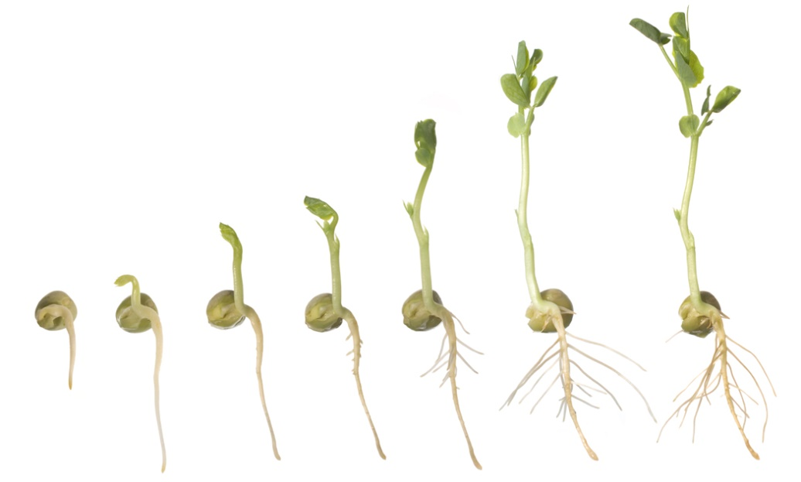

BIG QUESTION: How do a plant’s structures function to initiate and maintain life?
Draw a simple plant and label as many structures as you can. Provide a short description of what you believe the function of the each structure is as part of your drawing.
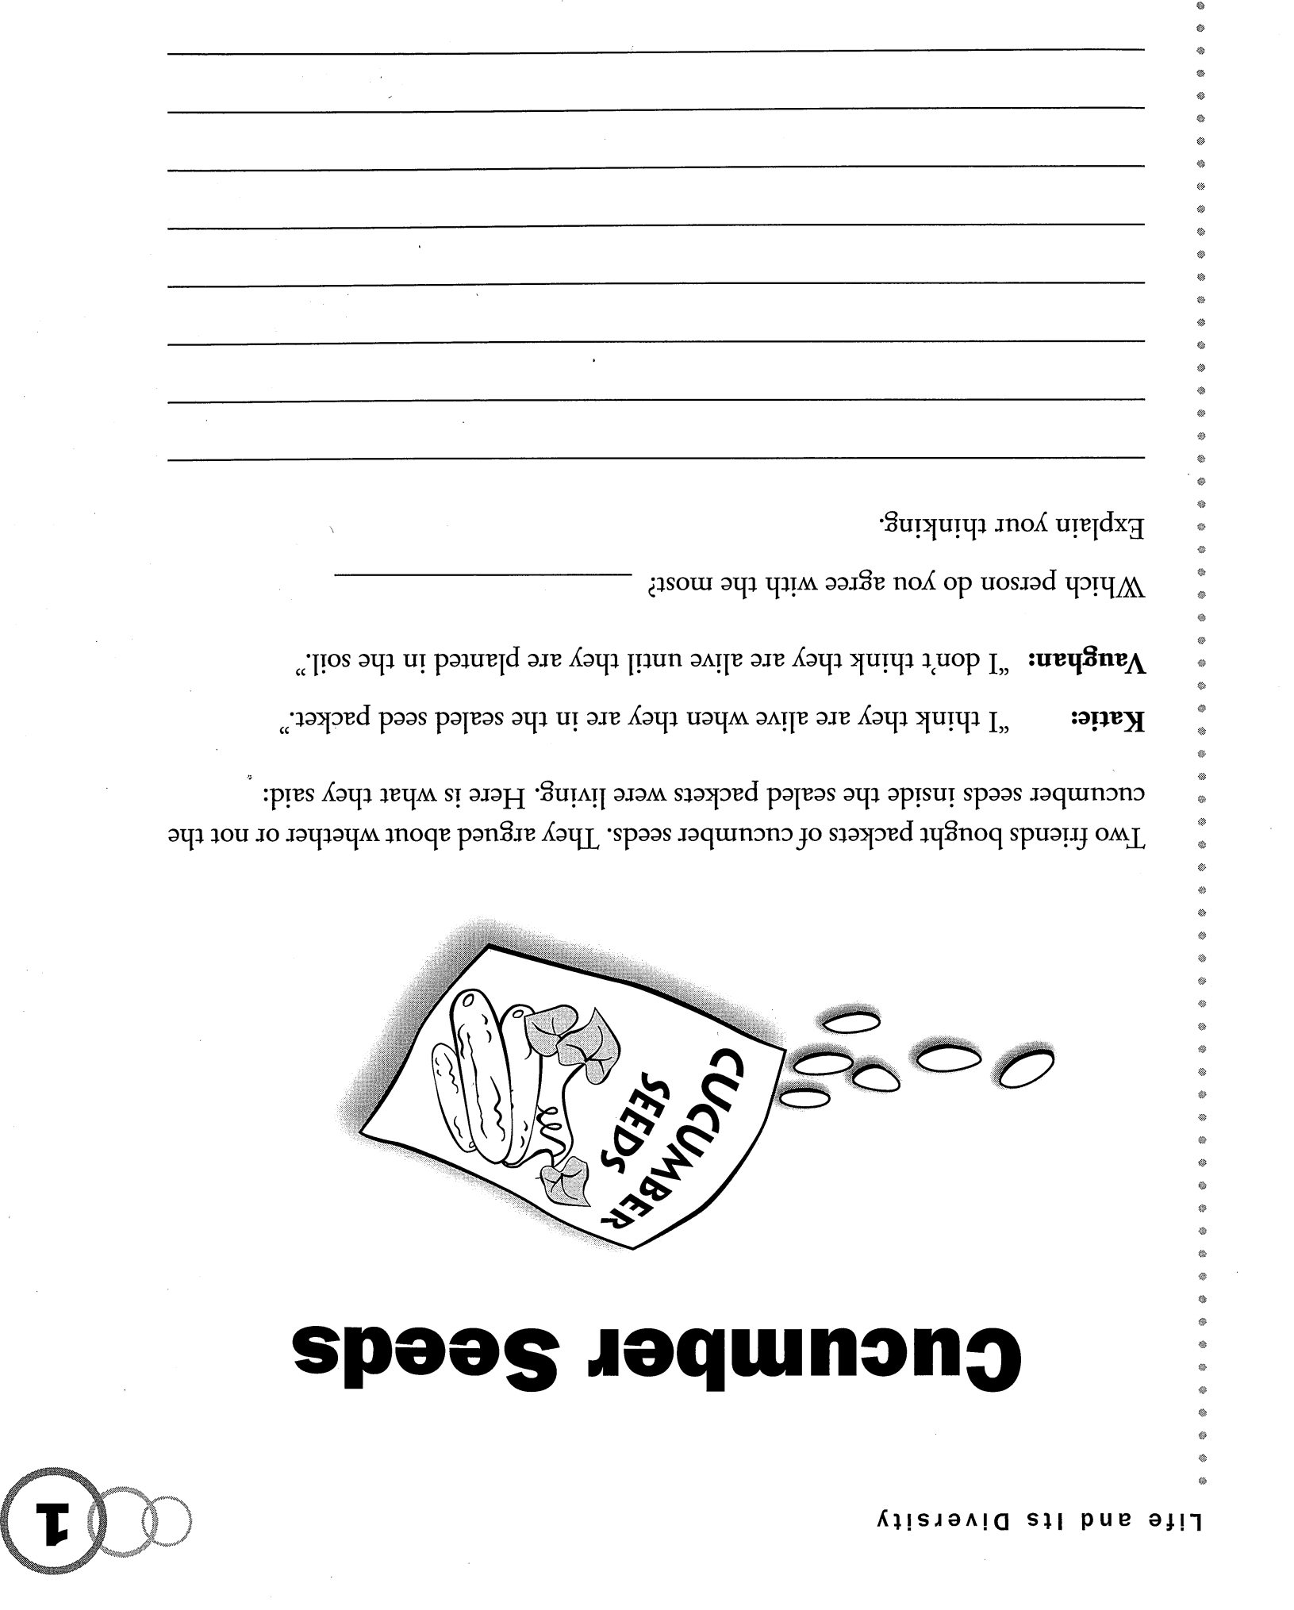
Focus Question: Are seeds alive?
Observations of Dry Lima Bean

Observations of Soaked Lima Bean

Observations of Germinated Seeds

Explanation:
__________________________________________

__________________________________________

__________________________________________

__________________________________________

__________________________________________

__________________________________________

__________________________________________

__________________________________________

__________________________________________

__________________________________________

__________________________________________

__________________________________________

*Revisit “Cucumber Seeds
Focus Question: What are some properties of seeds that are important to a plant’s survival?
Word Sort (Required for Germination?)

Question
Hypothesis
Experimental Plan

Data

Conclusion

Video – The Secret Life of Plants “Traveling”
Ways of Travel

Seed Structure

How Animals Help |  |  | Other Info
Reflection

What is the purpose of a seed?
_____________________________________________________________
_____________________________________________________________

Do all plants produce seeds? Why or why not?
______________________________________________________________
__________________________________________________________________________________________________________________________________________________________________________________________

Why do you think plants produce seeds that can lie dormant instead of producing plants that germinate immediately? What is the survival value?
______________________________________________________________________________________________________________________________________________________________________________________________________________________________________________________________________________________________________________________

Make a Claim (about a property of seeds that is important for survival)

Focus Question: How is the structure of roots important to a plant?
Observations

Root Cells
100X |  |  | 400X
What Do You Think?
______________________________________________________________
______________________________________________________________________________________________________________________________________________________________________________________________________________________________________________________________________________________________________________________
______________________________________________________________
______________________________________________________________
______________________________________________________________

Reading “Seeds and Roots”
Draw a picture (or pictures) to represent something you learned from each section of the reading. It cannot ONLY be the pictures that are already there!
Dormancy |  |  | Germination
Root System |  |  | Water
Support |  |  | Energy Storage
Summarize the Main Idea of the Passage
__________________________________________
__________________________________________
__________________________________________
__________________________________________
__________________________________________
__________________________________________
__________________________________________
__________________________________________

(Make a claim regarding the importance of roots)

Focus Question: What happens to water when it is taken up by a plant?
Know |  |  | Wonder
Plan:

Data:

(celery stem cross section)

(wilted celery leaf peel 400x) |  |  | (crisp celery leaf peel 400x)
Observations:

Conclusions:

Explanation:

__________________________________________

__________________________________________

__________________________________________

__________________________________________

__________________________________________

__________________________________________

__________________________________________

__________________________________________

Video – The Secret Life of Plants “Growing”
Transpiration

Leaves

Roots |  |  | Other Info
(Regarding where the water goes as a result of the transpiration process)

I claim

I know this because

Anatomy of a Green Leaf
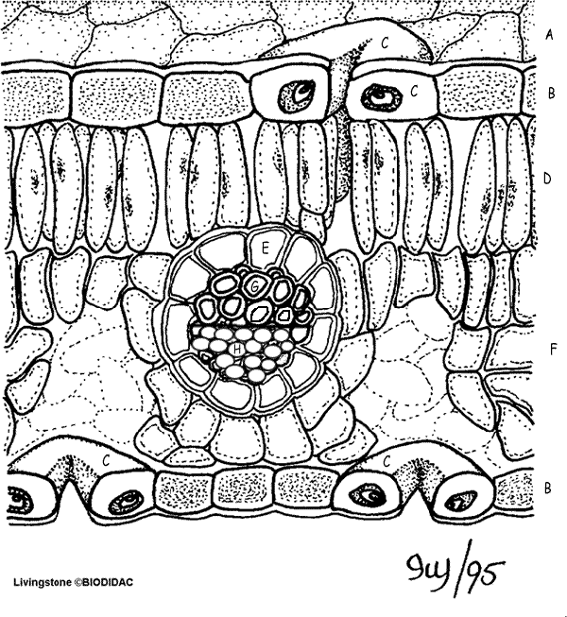
Structure |  | Function
A.
B.
C.
D.
E.
F.
G.
H.
Formative Assessment
Focus Question: How does the process of transpiration aid the plant with photosynthesis?
Photosynthesis Definition

Chemical Formula

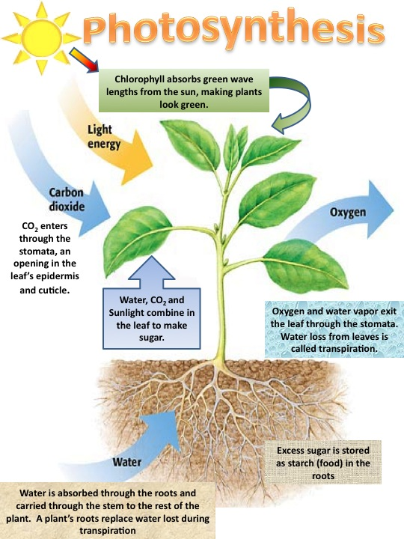
1.
2.
3.
4.
5.
6.
7.
8.
9.
10.
11.
12.
13.
14.
15.

15.
14.
13.
12.
10.
11.
9.
4.
3.
2.
1.
5.
7.
8.
6.

Reading “Stems and Leaves”
Pre-Post Strategy
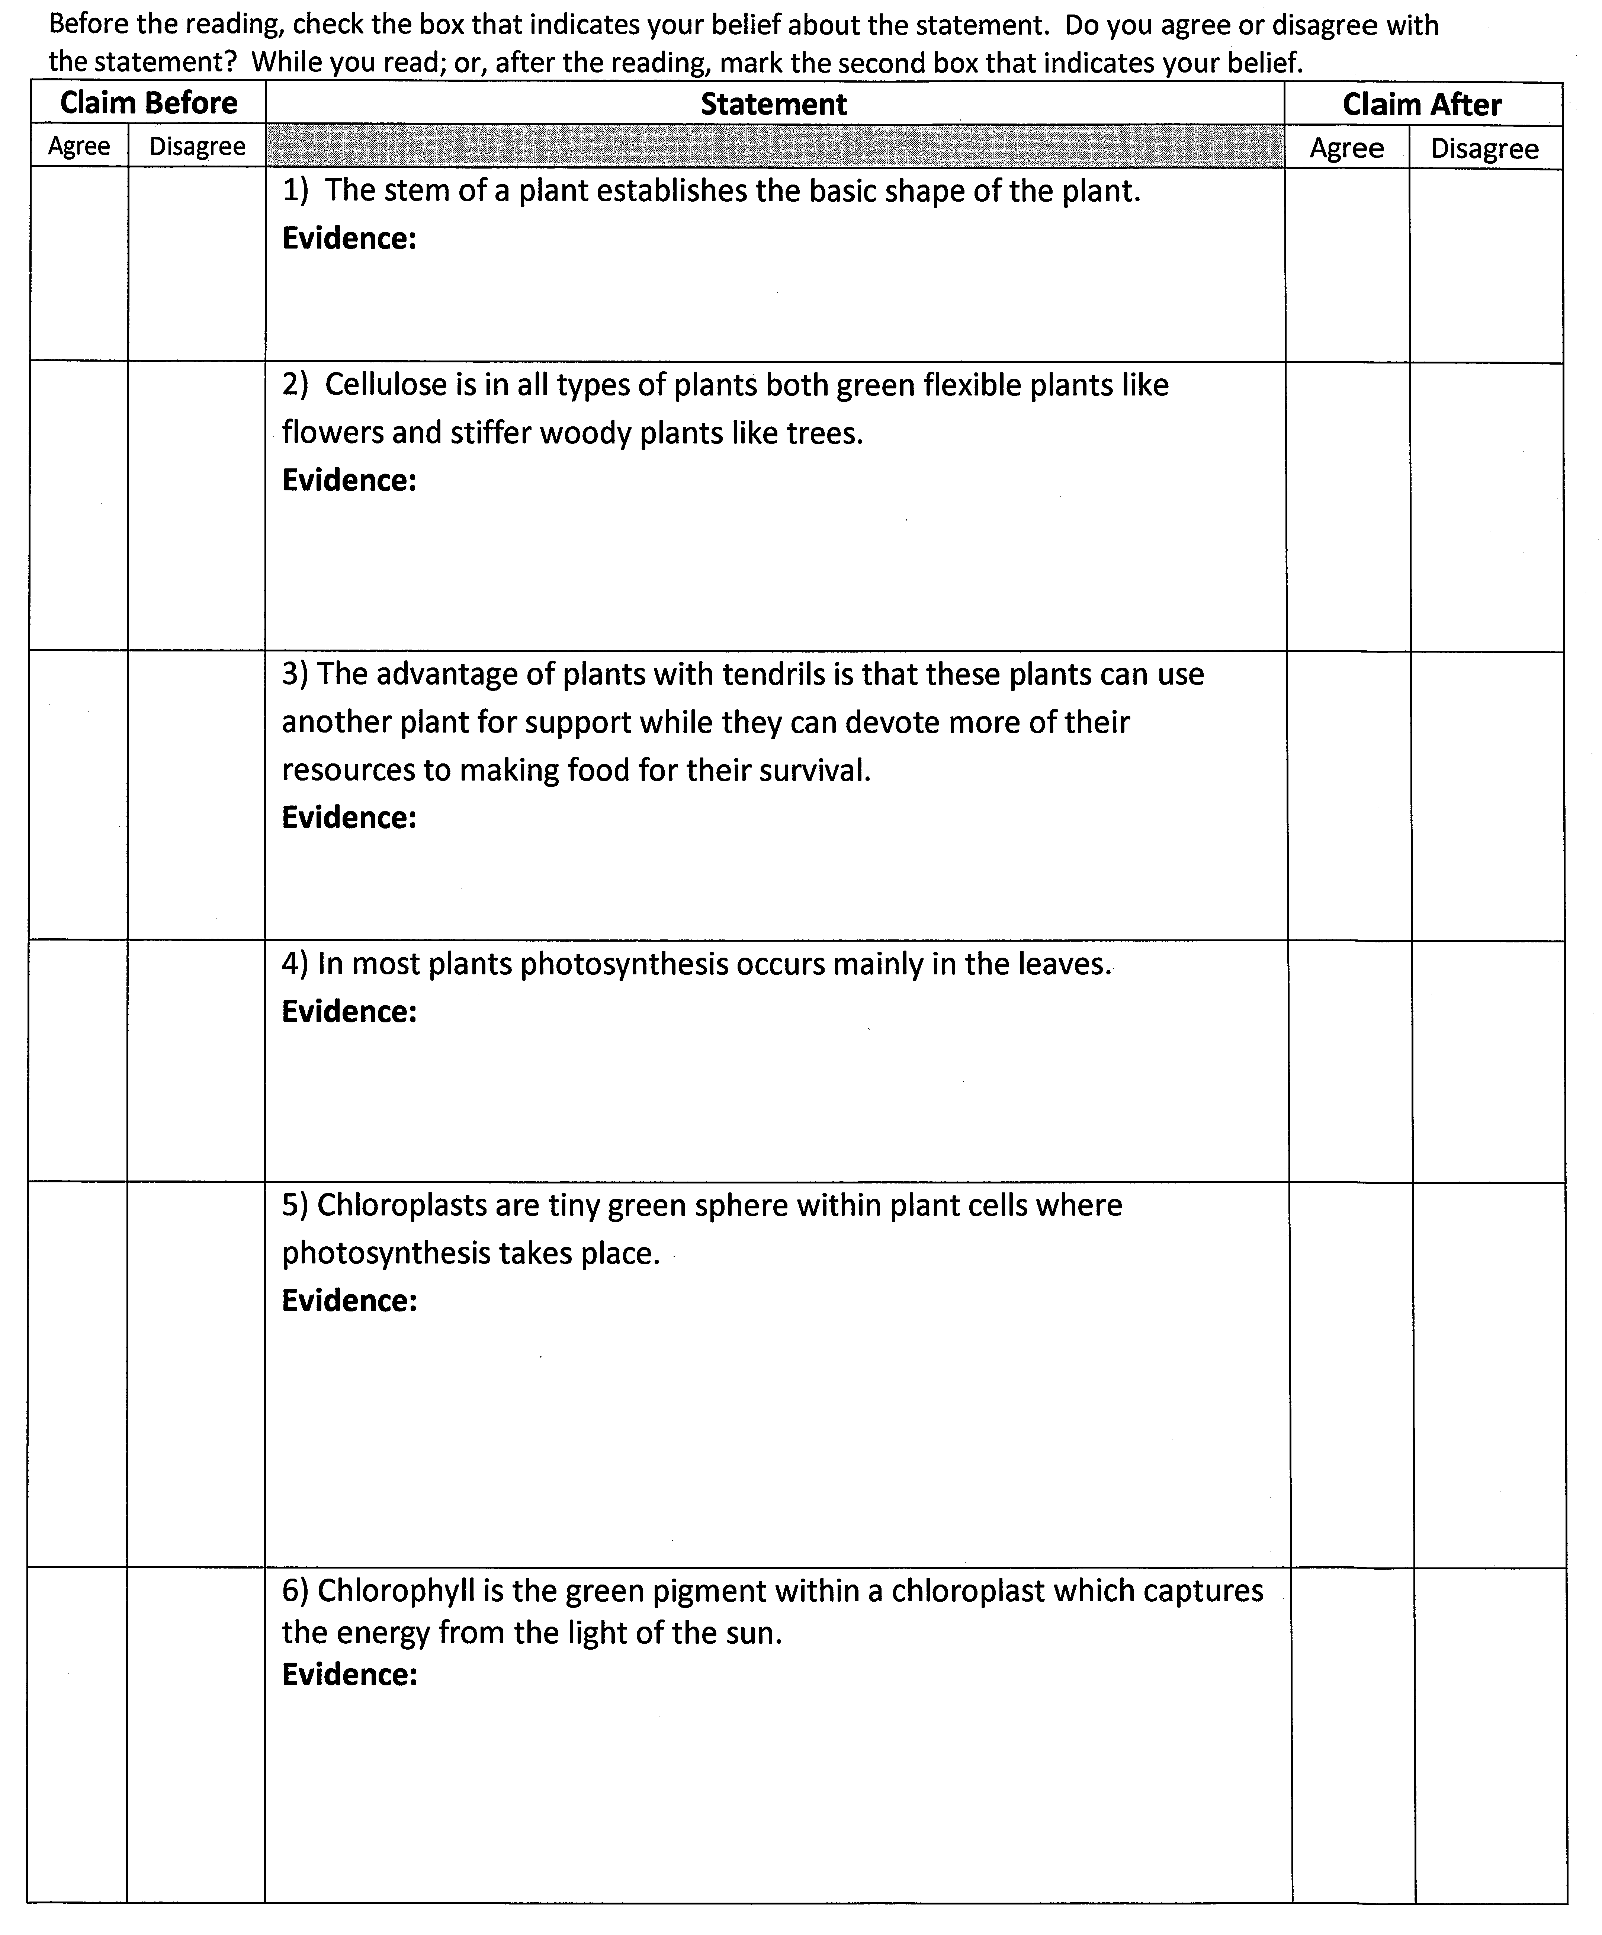
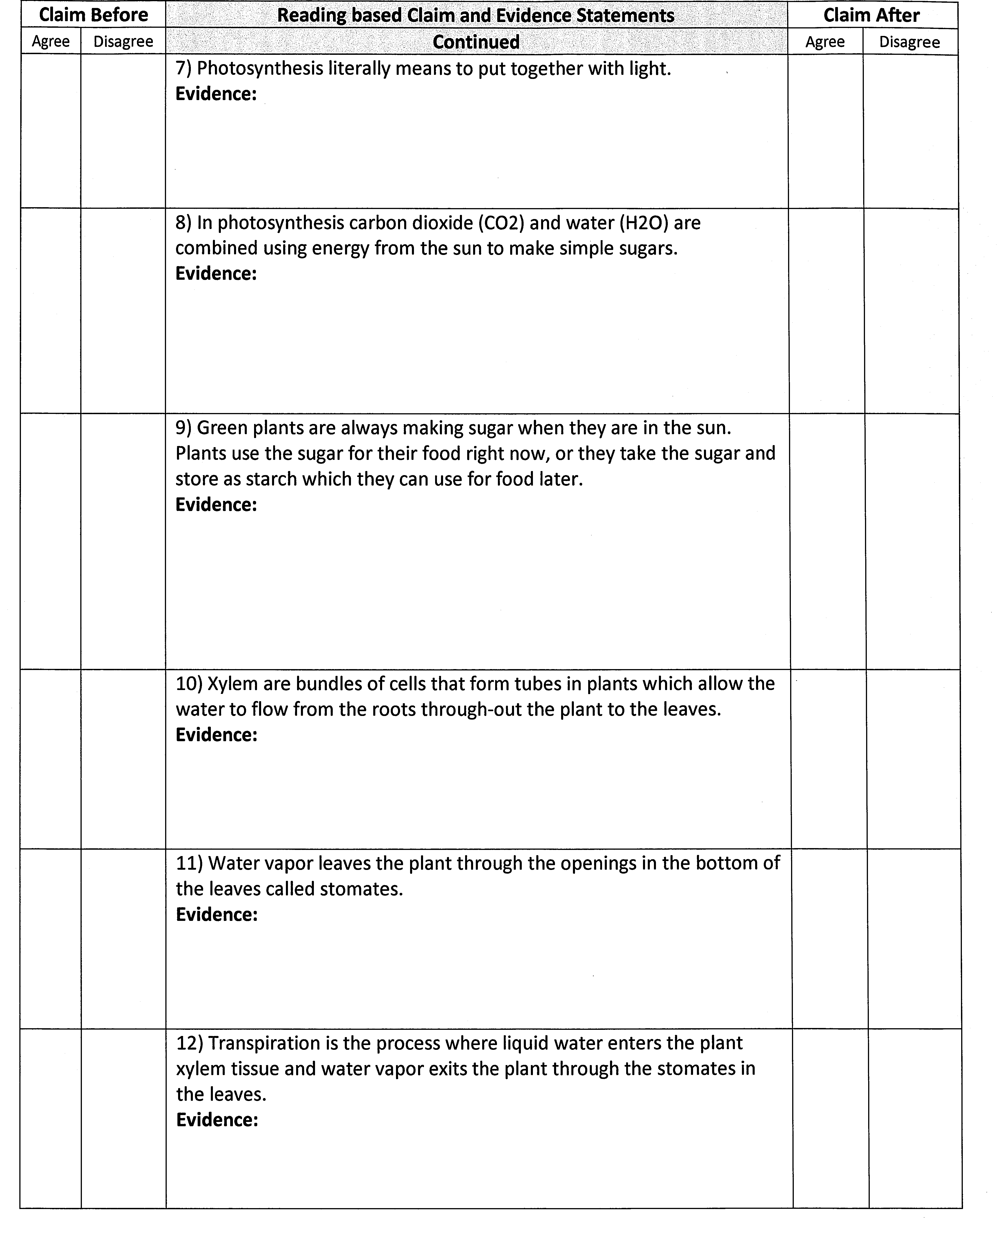
Anatomy of a Green Leaf
Where would the chlorophyll or chloroplasts be found?

Photosynthesis vs. Cellular Respiration
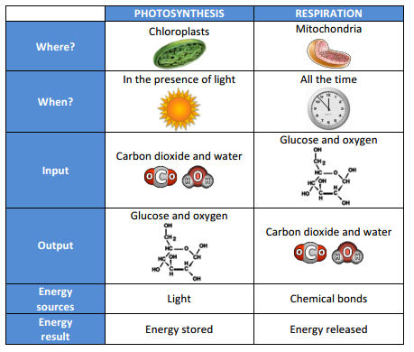
What Do You Notice?

Word Bank
______________________  ______________________  ______________________  ______________________  ______________________  ______________________  ______________________  ______________________  ______________________  ______________________  ______________________  ______________________ |  |  | ______________________  ______________________  ______________________  ______________________  ______________________  ______________________  ______________________  ______________________  ______________________  ______________________  ______________________  ______________________
______________________  ______________________  ______________________  ______________________  ______________________  ______________________  ______________________  ______________________  ______________________  ______________________  ______________________  ______________________  ______________________ |  |  | ______________________  ______________________  ______________________  ______________________  ______________________  ______________________  ______________________  ______________________  ______________________  ______________________  ______________________  ______________________  ______________________
Content
__________________________________________

__________________________________________

__________________________________________

__________________________________________

__________________________________________

__________________________________________

__________________________________________

__________________________________________

__________________________________________

__________________________________________

__________________________________________

Question |  |  |  | How do a plant’s structures function to initiate and maintain life?
Claim
Evidence

Analysis
 |  |  | Claim  A statement or conclusion that answers the original question/problem. |  | Evidence  Sufficient and appropriate scientific data/information and/or personal information or experiences that supports the claim. |  | Analysis  A justification that connects the evidence to the claim by using appropriate and sufficient scientific principles and vocabulary.
 | 0 |  | Does not make a claim, or makes an inaccurate claim. |  | Does not provide evidence, or only provides inaccurate evidence or vague evidence (i.e. the data shows me it is true) |  | Does not provide an analysis, or only provides an irrelevant analysis.
 | 1 |  | Makes an accurate claim but vague or incomplete claim. |  | Makes a general statement and does not include specific data. |  | Repeats evidence and links it to the claim, but does not include scientific principles and/or vocabulary
 | 2 |  | Makes an accurate and complete claim. |  | Provides 1 piece of evidence to support their claim |  | Connects evidence to the claim using scientific principles or vocabulary but not both.
 | 3 |  | Claim is exceptionally well done and able to be understood minus the question |  | Provides 2 or more pieces of evidence to support their claim |  | Connects evidence to the claim using scientific principles and vocabulary.

