STEM Science Notebook
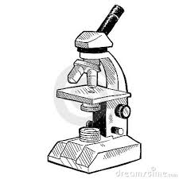
Diversity of Life
Investigation 2
BIG QUESTION: How do scientists use a microscope as an extension of their senses to make accurate observations, study organisms and carry out investigations?
Part 1: Meet the Microscope
Focus Question: What are the parts of a microscope and how does a scientist handle, use, and observe objects through a microscope?
(Demonstration of Handling/Setup)
What I notice:

Rules:

(Demonstration of Use)
What I notice:

Rules:

(Demonstration of Cleaning)
What I notice:

Rules:

Why is this important?

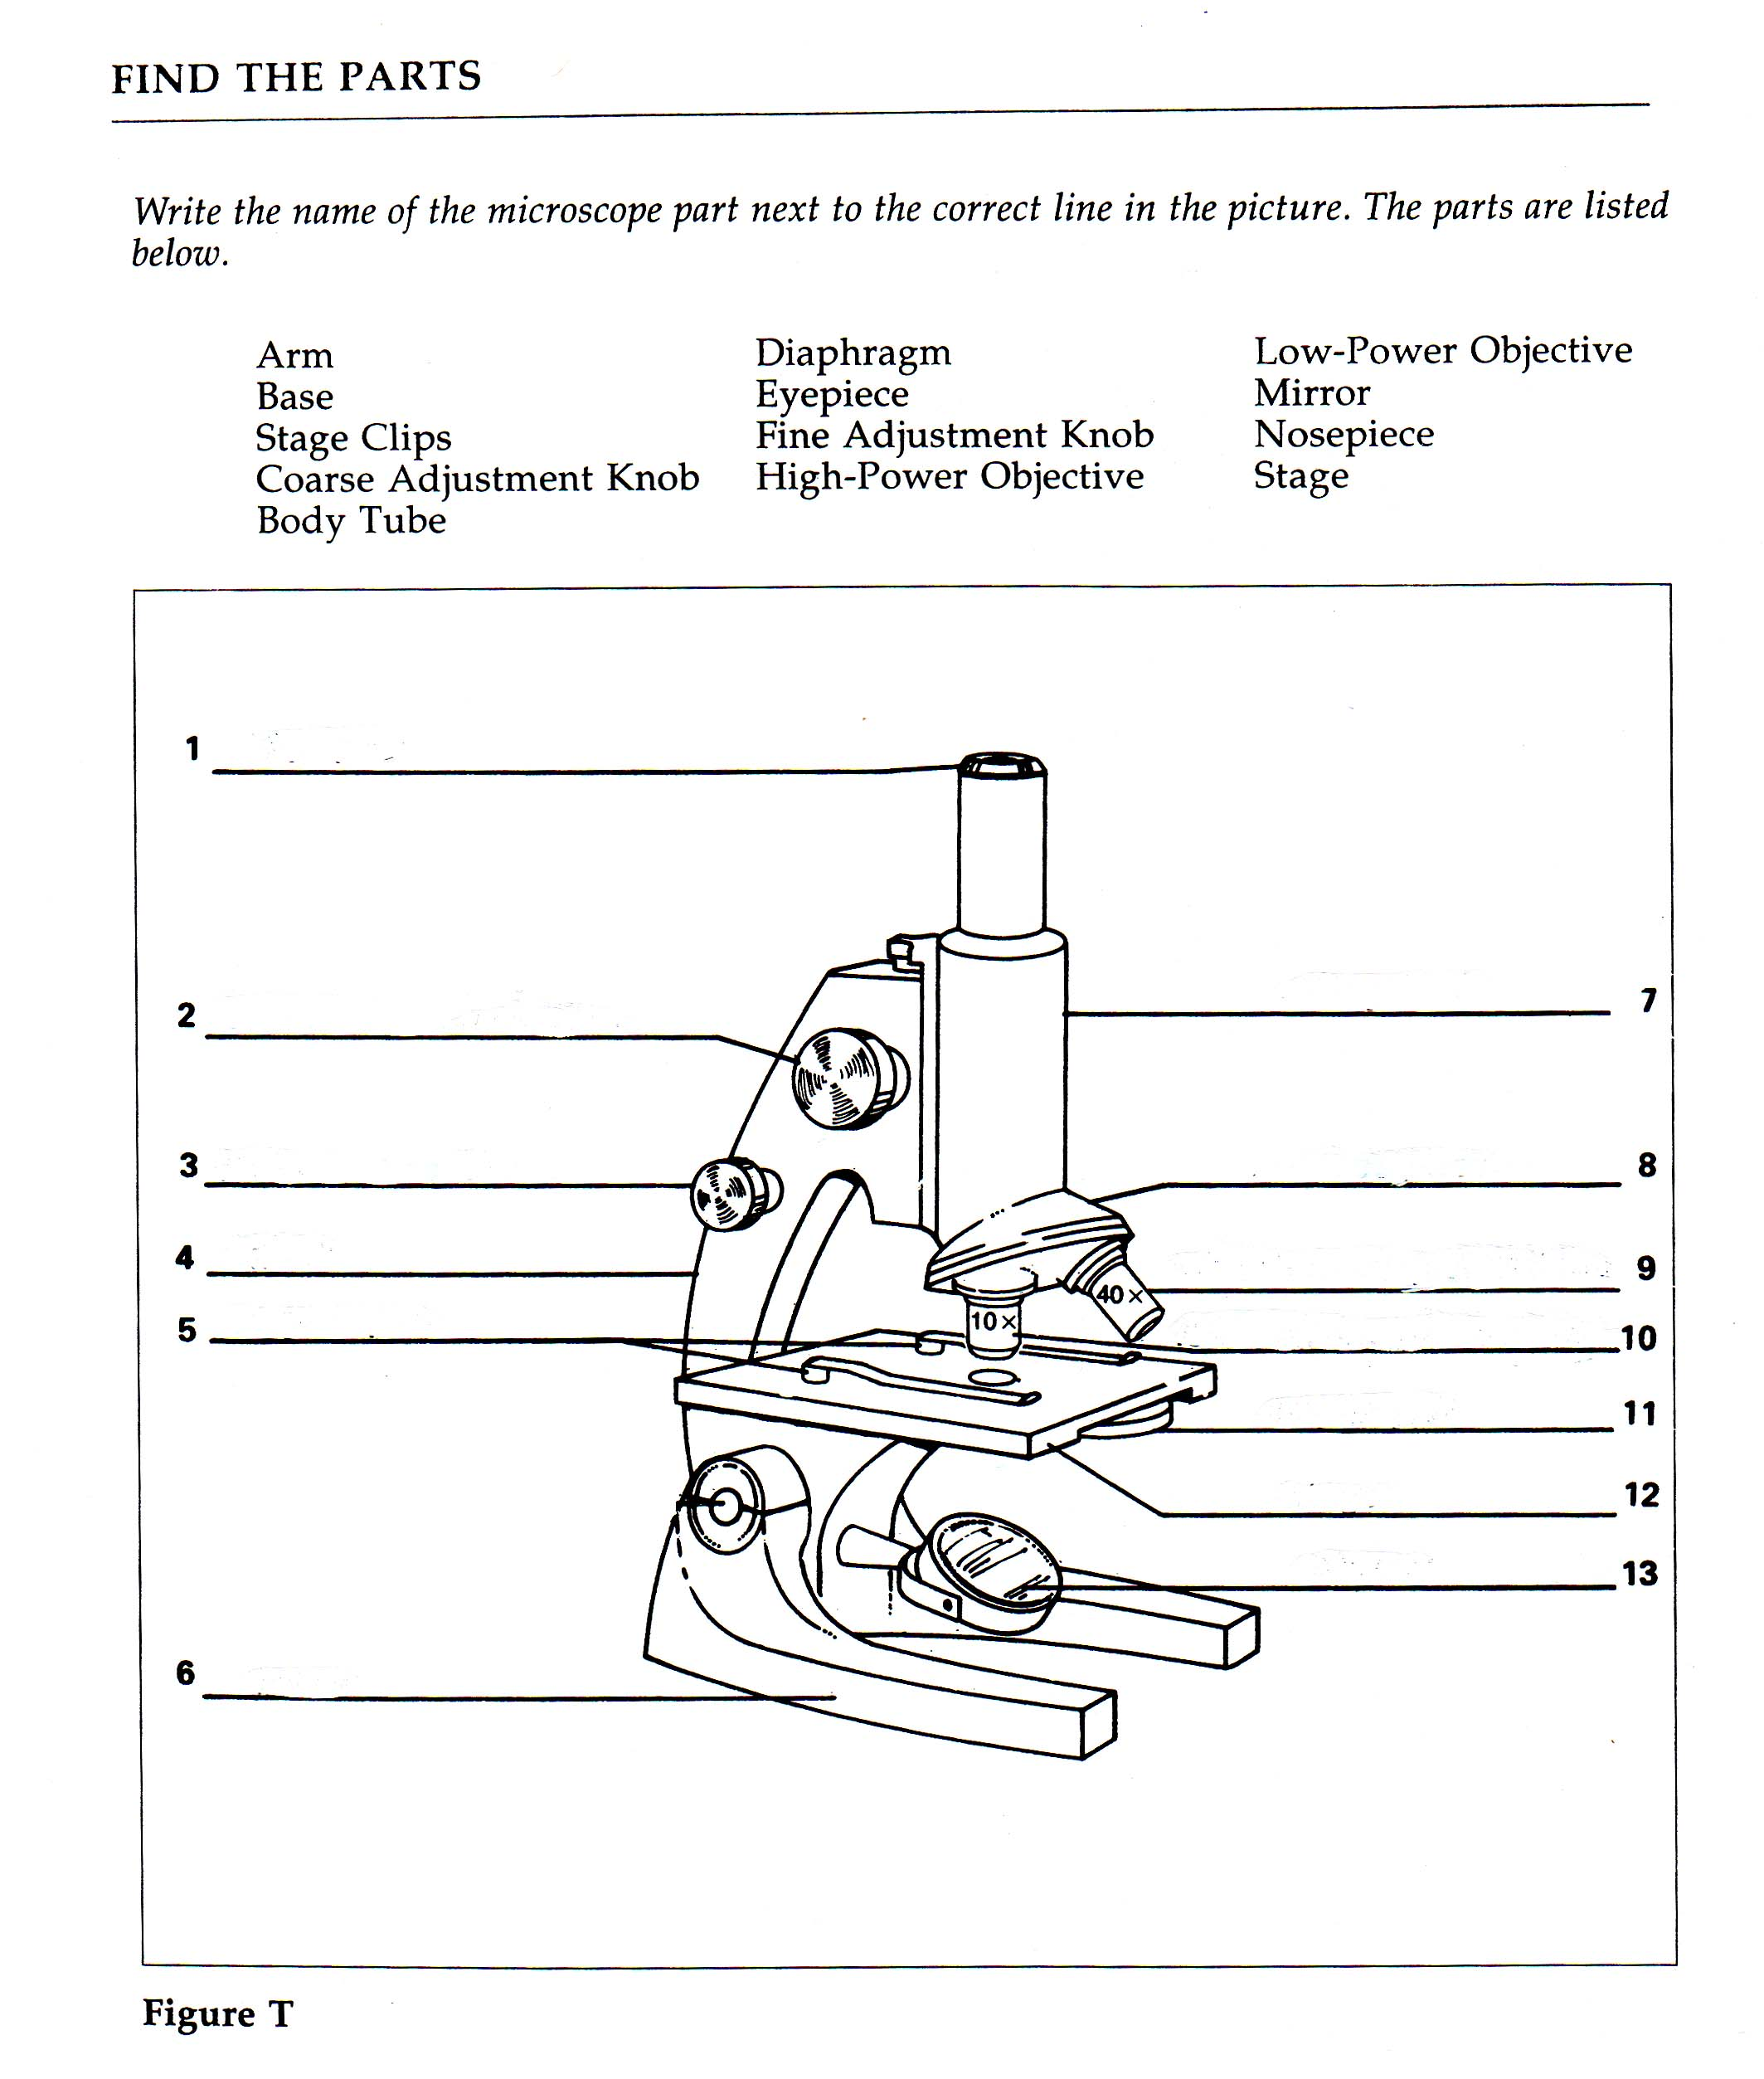
Focus Question: What materials are used to support the use of a microscope and how do we organize and care for them properly?
List of Materials | Special Instructions/Use
1. | 1.
2. | 2.
3. | 3.
4. | 4.
5. | 5.
6. | 6.
7. | 7.
8. | 8.
9. | 9.
10. | 10.
Label the diagram below using the numbers from above.
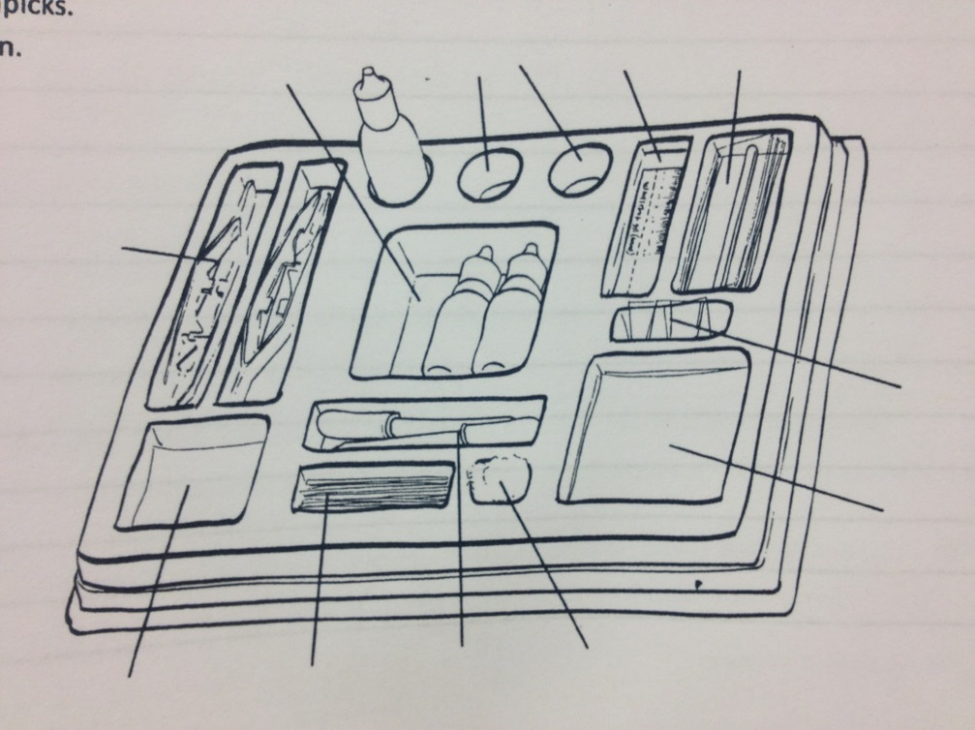

Part 2: Using the Microscope
Focus Question: What is the relationship between the orientation and appearance of an object on the stage, and the orientation and appearance and of the object in the field of view?
Plan:

Field of View

Draw what you see.

What shape is the field of view?
Repeat your plan with a larger letter e and draw what you see.
- What do you notice?

Make a claim about the field of view and orientation
I claim

I know this because

Focus Question: What is the relationship between the movement of an object on the stage, and the movement of the object in the field of view?
1. Set the objective lens to 4x
2. Place the dry-mount slide of the letter e on the stage of the microscope.
3. Center the image.
4. Move the slide away from you.
- What direction did the image move?
_______________________________

- Draw an arrow in the circle to indicate the direction the image moved.
Field of View
5. Move the slide to the right.
- What direction did the image move?
_______________________________

- Draw an arrow in the circle to indicate the direction the image moved.
Field of View
Make a claim about the relationship between the movement of an object on the stage and the movement of the object in the field of view.
I claim

I know this because

Focus Question: Is it possible to determine the size of an object using the field of view?
Plan:

Data:

Explanation:

Prediction:

Focus Question: How do you calculate the total magnification at 4x, 10x and 40x?
What I Notice:

Video Notes – “Wet Mount”
__________________________________________
__________________________________________
__________________________________________
__________________________________________
__________________________________________
__________________________________________
__________________________________________
__________________________________________
__________________________________________
__________________________________________
__________________________________________
Field of View and Magnification
The width of one square in the nylon netting material (measured with the millimeter ruler) is________________________________.

Part 1: The 4x objective
- Place the netting and ruler slide on the stage of the
microscope.
2. Select the 4x objective.
- Draw exactly what you see in the field of view.
- What is the width of the field of view?
- What is the width of one mesh square?
- What is the total magnification with this
objective lens?
- Mark 1 mm on the scale below the field of view.
Part 2: The 10x objective
- Select the 10x objective.
- Draw exactly what you see in the field of view.
- What is the width of the field of view?
- Estimate the width of one mesh square to the nearest 0.1 mm.
- What is the total magnification with this
objective lens?
- Mark 1 mm on the scale below the field of view.

Part 3: The 40x objective
- Select the 40x objective.
- Draw exactly what you see in the field of view.
- What is the width of the field of view?
- Estimate the width of one mesh square to the nearest 0.1 mm.
- What is the total magnification with this
objective lens?
- Mark 1 mm on the scale below the field of view.
Calculations:

Explanation:

Make a claim about the field of view and size or magnification.
Focus Question: What is focal plane?
Elicit:

Part 1: Focus on layers of ribbon
- Make a wet mount of three layers of ribbon.
- Set the objective lens for 100x magnification.
- Focus on the top layer of ribbon.
Then use the fine focus to focus down through the layers.
- How many layers can you get into focus at one time? __________
- Which direction do you turn the right-hand fine focus to focus down through the layers?
- Use colored pencils to draw exactly what you see when the middle layer is in focus.

Field of view
What I Notice:

I think focal plane means…

I think this because…

Explanation:

Part 2: Mystery ribbons
- Make a wet mount of three layers of ribbon. Keep the order a secret. Record the order of the ribbons from TOP to BOTTOM on the lines provided in the box to the left.
- Trade mystery-ribbon slides with another team.
- Use your microscope to determine the order of the colored ribbons used to make their mystery-ribbon slide. Record the colors and the order in the box to the right.

Our Slide Mystery Slide
Top
2
3

Top
2
3

How did you figure out which ribbon was on the bottom?

Microscope Practice
1. Observe the color photograph.
- Make a dry mount of a piece of colored photo.
- Draw and color what you see.
- Compare the colors with and without the microscope.

Field of View
Observations: (focal plane, orientation, field of view, etc.)

Magnifcation: ______________ x
Estimated size of what you are viewing:

2. Observe the feather.
- Prepare a dry mount of the feather. Use a second slide as a coverslip.
- View the feather tip using the 10x objective.
- Draw what you observe.

Field of View
Observations: (focal plane, orientation, field of view, etc.)

Magnification: _____________x
Estimated size of what you are viewing:

Word Bank
__________________________________________
__________________________________________
__________________________________________
__________________________________________
__________________________________________
__________________________________________
__________________________________________
__________________________________________
__________________________________________
__________________________________________
__________________________________________
__________________________________________
__________________________________________
__________________________________________
__________________________________________
__________________________________________
Content
__________________________________________
__________________________________________
__________________________________________
__________________________________________
__________________________________________
__________________________________________
__________________________________________
__________________________________________
__________________________________________
__________________________________________
__________________________________________
__________________________________________
__________________________________________
__________________________________________
__________________________________________
__________________________________________

Question |  | How do scientists use a microscope as an extension of their senses to make accurate observations, study organisms and carry out investigations?
Claim
Evidence

Analysis
 |  | Claim  A statement or conclusion that answers the original question/problem. | Evidence  Sufficient and appropriate scientific data/information and/or personal information or experiences that supports the claim. |  | Analysis  A justification that connects the evidence to the claim by using appropriate and sufficient scientific principles and vocabulary.
 | 0 | Does not make a claim, or makes an inaccurate claim. | Does not provide evidence, or only provides inaccurate evidence or vague evidence (i.e. the data shows me it is true) |  | Does not provide an analysis, or only provides an irrelevant analysis.
 | 1 | Makes an accurate claim but vague or incomplete claim. | Makes a general statement and does not include specific data. |  | Repeats evidence and links it to the claim, but does not include scientific principles and/or vocabulary
 | 2 | Makes an accurate and complete claim. | Provides 1 piece of evidence to support their claim |  | Connects evidence to the claim using scientific principles or vocabulary but not both.
 | 3 | Claim is exceptionally well done and able to be understood minus the question | Provides 2 or more pieces of evidence to support their claim |  | Connects evidence to the claim using scientific principles and vocabulary.
7th Grade Argumentative Writing Rating Scale

CCSS.ELA-LITERACY.W.7.1
“Write arguments to support claims with clear reasons and relevant evidence.”
Rating | Description
4 | I can write arguments supported with clear, logical reasons and relevant evidence that creates cohesion and clarifies relationships among claims, reasons, and evidence.
3 | I can write arguments to support claims with clear reasons and relevant evidence.
2 | I can write arguments that partially support claims with reasons and evidence.
1 | I can introduce a claim(s) but am unable to support them with reasons and evidence.
0 | I am unable to write arguments and support claims with evidence.

Student self-reflection:
Date ________
My personal rating is a _______ because ____________________________________________

______________________________________________________________________________

_____________________________________________________________________________.

My goal for improvement is _______________________________________________________

_____________________________________________________________________________.
Teacher Comments:

