Name: _________________________________________ Date: ________
Circulatory System Stations

Watch It:

1 | 6
2 | 7
3 | 8
4 | 9
5

Explore It:

1 | 5
2 | 6
3 | 7
4 | 8

Read It:

1.

2.

3.

Organize it:

Teacher Initial-

Draw It:
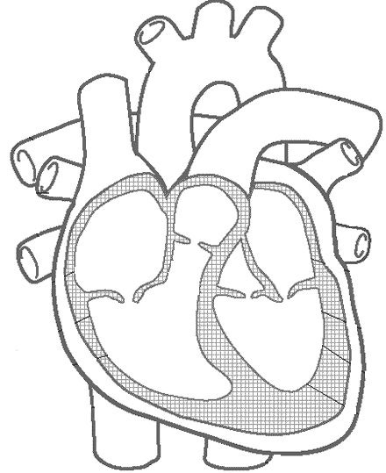
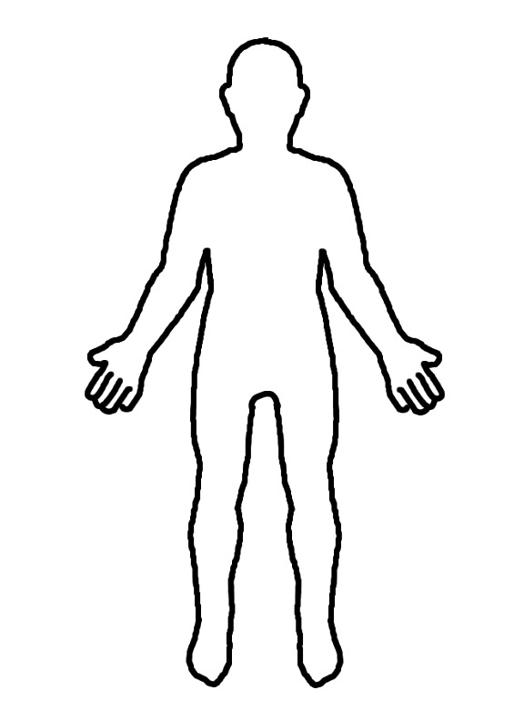

Research It:

Arteries:

Veins:

Capillaries:

Assess It:

Answer the Regents questions at your seat after you have visited all of the other stations. If your seat is occupied by a station, please sit elsewhere.

