NAME_KEY_________________ DATE_________ PERIOD_________

**Cell Membrane Coloring Worksheet**

***Composition of the Cell Membrane & Functions***

The cell membrane is also called the plasma

membrane and is made of a phospholipid bilayer . The

phospholipids have a hydrophilic (water attracting) heads and

two hydrophobic (water repelling) tails. The head of

a phospholipid is made of an alcohol and glycerol group, while the

tails are chains of fatty acids. Phospholipids can move around

and allow water and other non-polar molecules

to pass through into or out of the cell. This is known as simple diffusion because it does not require energy and the

water or molecules are moving with/down the concentration gradient. ***SKETCH AND LABEL*** a phospholipid coloring the heads red and the tails blue.

PHOSPHOLIPID

Another type of lipid in the cell membrane is cholesterol

that makes the membrane more fluid. Embedded in the phospholipid bilayer are proteins that also aid in diffusion and in cell recognition. Proteins called integral proteins go all the way through the bilayer, while perpheral proteins are only on one side. Integral proteins are also called transmembrane proteins. Large molecules like proteins

or carbohydrates use proteins to help move across cell membranes. Some of the membrane proteins have carbohydrate parts

attached to help cells in recognize each other and certain molecules.

List 4 functions of the cell or plasma membrane:

|  |  |
| --- | --- |
| a. | Cell signaling |
| b. | Selective transport |
| c. | Excretion of wastes |
| d. | Structural support |

Correctly ***color code and identify*** the name for each part of the cell membrane.

|  |  |  |  |
| --- | --- | --- | --- |
| **Letter** | **Name/Color** | **Letter** | **Name/Color** |
| A | Phospholipid bilayer (no color) | H | Peripheral protein (red) |
| B | Integral protein (pink) | I | Cholesterol (blue) |
| F | Fatty acid tails (orange) | C | Glycoprotein (green) |
| G | Phosphate heads (yellow) | E | Glycolipids (purple) |

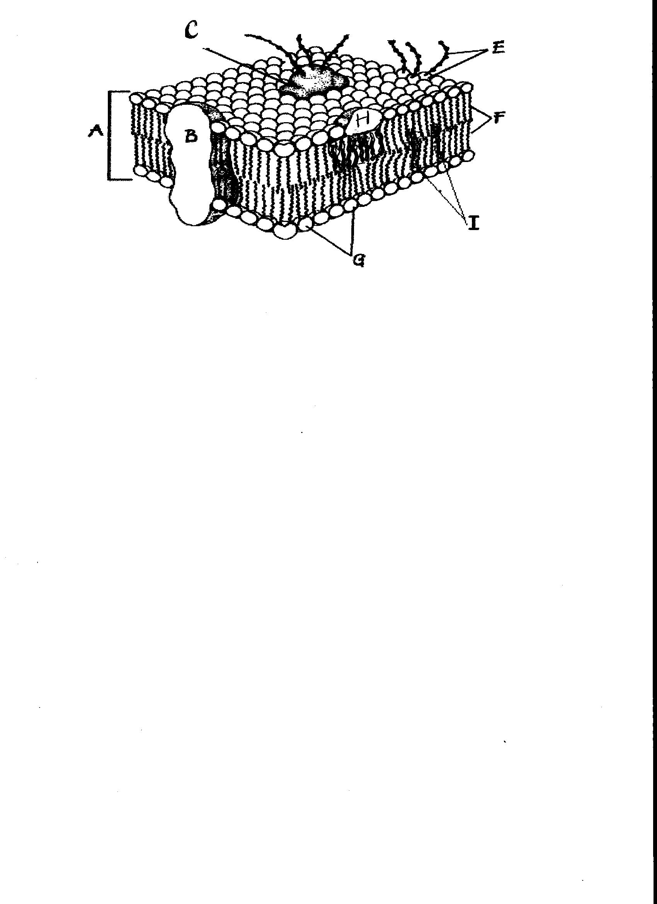

***Match*** the cell membrane structure or its function with the correct letter from the cell membrane diagram.

|  |  |  |  |
| --- | --- | --- | --- |
| **Letter** | **Structure/Function** | **Letter** | **Structure/Function** |
| G | **Attracts water** | F | **Repels water** |
| I | **Helps maintain flexibility of membrane** | G & F | **Make up the bilayer** |
| C & E | **Involved in cell-to-cell recognition** | B | **Help transport certain materials across the cell membrane** |

***Osmosis and Tonicity***

Define osmosis **THE MOVEMENT OF WATER ACROSS A SELECTIVELY PERMEABLE MEMBRANE FROM AN AREA OF HIGH CONCENTRATION TO AN AREA OF LOW CONCENTRATION.**

In which direction does water move across membranes, up or down the concentration gradient? **DOWN**

Define these 3 terms:

|  |  |
| --- | --- |
| a. isotonic- | **THE CONCENTRATION OF DISSOLVED PARTICLES ARE THE SAME INSIDE AND OUTSIDE THE CELL – THERE IS NO OVERALL CHANGE IN THE CELL SIZE** |
| b. hypertonic | **THE CONCENTRATION OF DISSOLVED PARTICLES ARE HIGHER OUTSIDE THE CELL THAN INSIDE THE CELL– WATER WILL LEAVE THE CELL IN AN ATTEMPT TO DILUTE THE OUTSIDE CONCENTRATION** |
| c. hypotonic | **THE CONCENTRATION OF DISSOLVED PARTICLES ARE LOWER OUTSIDE THE CELL THAN INSIDE THE CELL– WATER WILL ENTER THE CELL IN AN ATTEMPT TO DILUTE THE INSIDE CONCENTRATION** |

***Use arrows*** to show the direction of water movement into or out of each cell. ***Color and label*** the cell in an isotonic environment light blue, the hypotonic environment yellow, and the hypertonic environment light green.



***Match the description or picture with the osmotic condition:***

|  |  |
| --- | --- |
| ***A. Isotonic*** | **C solution with a lower solute concentration** |
|  | **A solution in which the solute concentration is the same** |
| ***B. Hypertonic*** | **A condition plant cells require** |
|  | **A condition that animal cells require** |
| ***C. Hypotonic*** | **C red blood cell bursts (cytolysis)** |
|  | **C plant cell loses turgor pressure (Plasmolysis)** |
|  | **B solution with a higher solute concentration** |
|  | **A plant cell with good turgor pressure** |
|  | **C solution with a high water concentration** |

***Label the tonicity for each solution (isotonic, hypotonic, or hypertonic):***

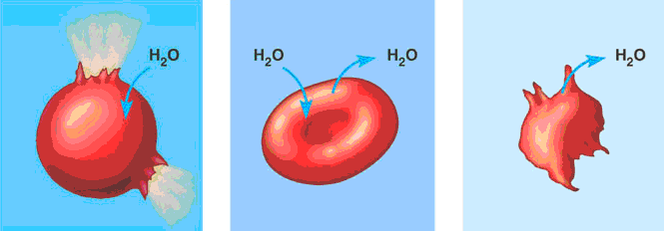

***Hypotonic Isotonic Hypertonic***

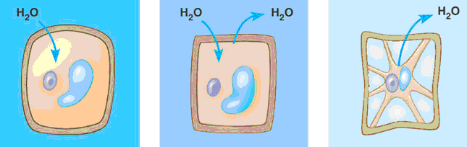

***Hypotonic Isotonic Hypertonic***

***Transport Requiring Energy***

What type of transport is represented by the following picture? Active transport

What energy is being used? ATP

In which direction (concentration gradient), is the movement occurring? Against/up

***Color*** the internal environment of the cell yellow. ***Color and Label*** the transport proteins red and the substance being moved blue.



One type of active transport is called the sodium-potassium pump which helps muscle cells contract. This pump uses proteins to move ions against/up the concentration gradient. The protein that is used to pump the ions through is called a transmembrane/integral protein and it changes its shape to move the ions across the cell membrane. ***Label and color*** the carrier proteins red and the ions green<http://www.biologyjunction.com/cell%20membrane%20coloring%20worksheet.doc>