Castle Learning Assignments

You will complete the assignment titled Cell review #3. You will have from today until next Friday, December 12th to complete the assignment.

Go to the website www.castlelearning.com . This will work on a phone or tablet, as well as the computer! When you go to log in enter the following information:
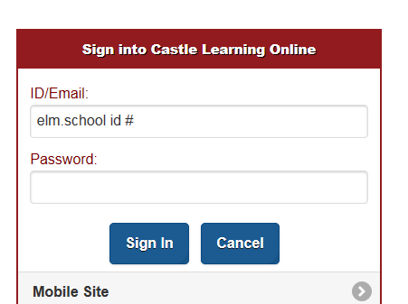
ID: elm. your school ID #
Password: if it is your first time logging in leave this BLANK and hit sign in. You will be asked to make a password. If you have signed in before, use the password you already created. If you can not remember it, please see me and I can reset it.

*If for some reason you can not log in, please see me as soon as possible, so we can fix the problem!

Choose Cell Review #3 and complete that assignment. You only have until next Friday. After that the assignment will be closed.

Use a computer or smartphone at home to complete the assignment. Use a computer at school. Visit the library or a friend’s house. You have a week to figure it out if you have no computer available at home. If you really can not complete the assignment, please see me, and I will gladly help you out

