Name:___________________________________ Date:_____________

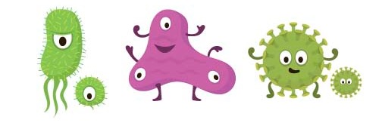

Watch the video at the link found in the I drive. Examine the info graphic that is also on the I drive. Explain what it means for bacteria to be antibiotic resistant and how this occurs.





How do you think bacteria normally respond to antibiotics?

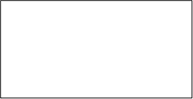

What do you think it means for bacteria to be resistant to antibiotics?



How is antibiotic resistance related to natural selection and evolution?



How can we prevent antibiotic resistance?

