Name _______________________
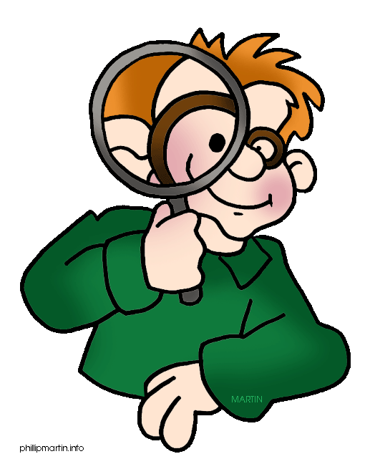
Date ________________________
Period _____

The Scientific Method: An Introductory Reading

Do you like detective or mystery stories? Why do you like them? Detectives and investigators decipher the clues and try to figure out a logical explanation for what happened and, above all, who did it! Or do you like to play games that make you think and figure out a strategy or an answer? If you enjoy mysteries and figuring out answers to questions or problems, then the chances are very good that you already know something about the scientific method. It’s just that you haven’t called it the scientific method yet.

The scientific method is an organized way to investigate something that interests you. It could be a question about why something happens or it could be a problem that you want to solve. In either case, the scientific method starts with a question. The question you ask needs to be something you can measure so you can compare results. There might already be a good answer to your question. So it’s important to do background research find out what’s already written about your question. A good detective will use resources like the library and the Internet.

The next step in the scientific method is to formulate a hypothesis. A hypothesis is an educated guess about the possible answer to your question. For example, “If I give my plants fertilizer in the spring, they will have more flowers.” is a simple hypothesis about how plants grow. A hypothesis must be measureable. In this example, you can count the number of flowers. What are some of the other variables or factors that might be responsible for plant growth? Did you come up with water, light and temperature? Take a moment to write some other hypotheses about plants.

The next step in the scientific method is to show that the hypothesis is correct (true) or incorrect (false). Hypotheses are sometimes true but many times they turn out to be false. Scientists do not give up! They are patient and persistent and keep looking for answers. To show a hypothesis is true or false, you need to design and complete an experiment. Scientists must be careful in how they design an experiment. They must make sure the experiment tests exactly what the hypothesis states. A proper experiment changes only one variable or factor in the experiment at a time.
An experiment is made up of two groups. One is called a control group and other is called an experimental group. The experimental group gets the variable being questioned tested on it. The control group does not. If a scientist was testing the flower and fertilizer hypothesis, she would select one species of flower to test with and buy a dozen plants. Six of the plants would be the control group and six the experimental group. The experimental group would get a measured amount of fertilizer on a regular schedule. The control group would not get any fertilizer. The list of other variables (water, light and temperature) need to be kept the same throughout the experiment. So all the plants would be kept in the same greenhouse and given the same amount of light and water. This will ensure that these variables do not influence the growth of the plants. The scientist would write down everything that she did. Keeping good detailed and accurate records is very important.

The scientist would conduct this flower experiment for a few weeks until the flowers bloomed. Then she would count the number of flowers on each plant. She would compare the number of flowers in the control group to those in the experimental group. The length of the experiment is important. It needs to be run long enough to collect sufficient data to analyze. Sample size is also important when designing an experiment. The more samples you have, the more reliable your results will be. Real science experiments use hundreds or thousands of experimental subjects to insure that the results apply to more than just a few subjects.

The next step in the scientific method is to analyze the results. Scientists take the data and use mathematics to analyze them. The results are then shown using tables, charts, graphs and pictures. Simply showing numbers from an experiment will not prove a hypothesis.

The last step in the scientific method is to report your conclusions. The conclusions summarize what you did, how you did it and the results. It will also tell if the hypothesis was correct or not. If not it would tell what your next step might be. Scientists publish their results in scientific journals for others to read. In science class your conclusions would be written up for your teacher to read or maybe even your classmates.

What happens if the experiment does not show that the hypothesis is true? Does that mean that the hypothesis is false? Absolutely not! Scientists are persistent. They will try different experiment. In the flower example, maybe we didn’t use enough fertilizer to make a difference. Maybe we didn’t use the right kind of fertilizer for the kind of plants we used. The next step might be to run another experiment with a larger amount of fertilizer.

Name ____________________________ Mrs. Stone
Date _____________________________ Science
Period ______

Directions: Answer the following questions based on the reading. Be sure to provide details from the reading to support your answers and write using complete sentences.

- What is the scientific method? ________________________________________________________________________________________________________________________________

- The author compares the scientific method with a detective. In what ways are they similar to each other? ________________________________________________________________________________________________________________________________________________________________________________________________________________________________________________________________

- According to the author, what are three important characteristics of a good experiment? ________________________________________________________________________________________________________________________________________________________________________________________________

- In paragraph 3 the author gives an example of a hypothesis about how plants grow. Write another hypothesis about how plants grow that the author could have given instead. ________________________________________________________________________________________________________________________________________________________________________________________________

- Why is it important to do background research about the question you want to research? ________________________________________________________________________________________________________________________________________________________________________________________________

- Why is it important to change only one variable at a time during an experiment? ________________________________________________________________________________________________________________________________________________________________________________________________

The steps of the Scientific Method are listed in the chart below. Write a description and list characteristics of each step as detailed in the text.

Steps | Description | Characteristics
Ask a
Question

Formulate a
Hypothesis

Design and Conduct an Experiment

Analyze the Results

Report Your Conclusions

The steps of the scientific method are:

Identify the Problem
Form a Hypothesis
Create an experiment
Perform an experiment
Analyze data
Communicate the Results

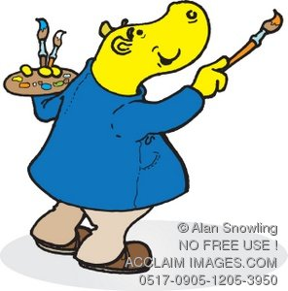
Use the letters provided to come up with a way of memorizing the steps of the scientific method. You should create a complete sentence. The sillier this sentence is, the better you will remember it! Use the example below to help you:

Pretty Hippos Can Paint Any Room.

What can you come up with?

P________________
H________________
C________________
P________________
A________________
R________________

Important Definitions:

Independent Variable: ____________________________________________________
__________________________________________________________________________________________________________________________________________________________________________________________________________________

Dependent Variable:_____________________________________________________
__________________________________________________________________________________________________________________________________________________________________________________________________________________

Control Group: _________________________________________________________
__________________________________________________________________________________________________________________________________________________________________________________________________________________

