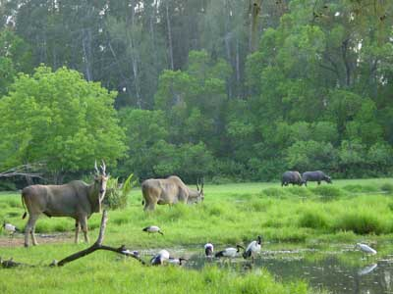
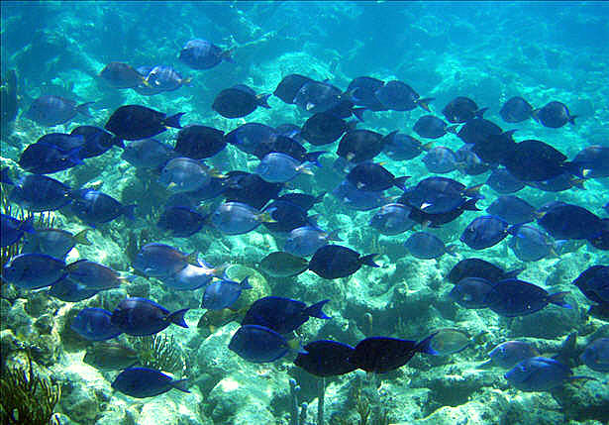
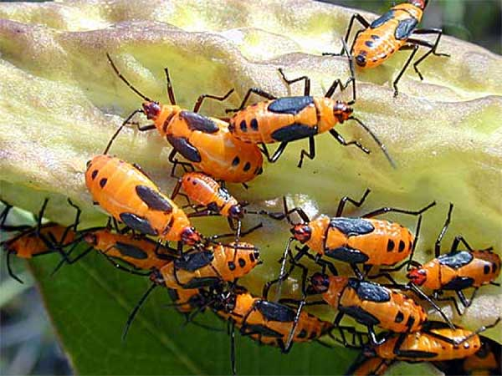
STEM Science Notebook

Populations and Ecosystems
Investigation 1
BIG QUESTION: What are some important concepts to consider when studying ecosystems and the factors needed to support an organism’s ability to survive and reproduce within their habitat?
What Do You See?

What Do You Think?

What Do You Think Now?

Focus Question 1: What factors do we need to consider when setting up an organism’s habitat?
Habitat

Habitat Considerations

Explanation
____________________________________________________

____________________________________________________

____________________________________________________

Focus Question 2: How can our observations of mealworms help us create a suitable habitat for them?
Observations
(What do you notice about the structures or behavior?)

Sketches

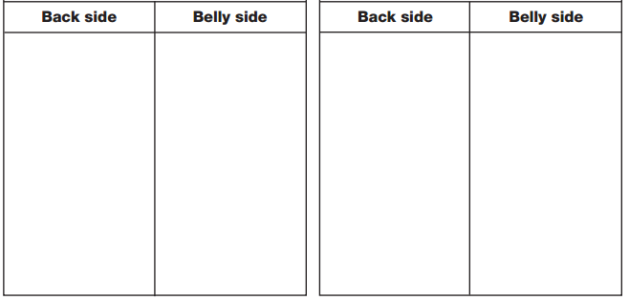

I wonder…..

Draw a Conclusion

Have our observations brought anything to mind that we should consider when we create the mealworm habitat?

Habitat Plan
Item |  | Purpose
Sketch of Final Habitat Plan

Focus Question 3: What is the sequence of the mealworm’s life cycle?
Observations
Date | Changes  (in environment, organisms or behaviors) |  |  |  | # of Bugs
Date | Changes  (in environment, organisms or behaviors) |  |  |  | # of Bugs
Word Bank
__________________________________________
__________________________________________
__________________________________________
__________________________________________
__________________________________________
__________________________________________
__________________________________________
__________________________________________
__________________________________________
__________________________________________
__________________________________________

Content
__________________________________________
__________________________________________
__________________________________________
__________________________________________
__________________________________________
__________________________________________
__________________________________________
__________________________________________
__________________________________________
__________________________________________
__________________________________________
__________________________________________
Make a Claim
Based upon your group’s observations of the mealworms, what changes did you observe in the bugs that you believe make up the stages of their life cycle? Draw a diagram below which represents the different stages or forms you observed and try to put them in the sequence that shows development from young to adult. Then make a claim about the life cycle.

I claim….

I know this because……

Final Number of mealworms _________________________
Focus Question 4: What do we need to know in order to study an organism in its natural ecosystem?
ecology

individual

population

community

ecosystem

abiotic

biotic

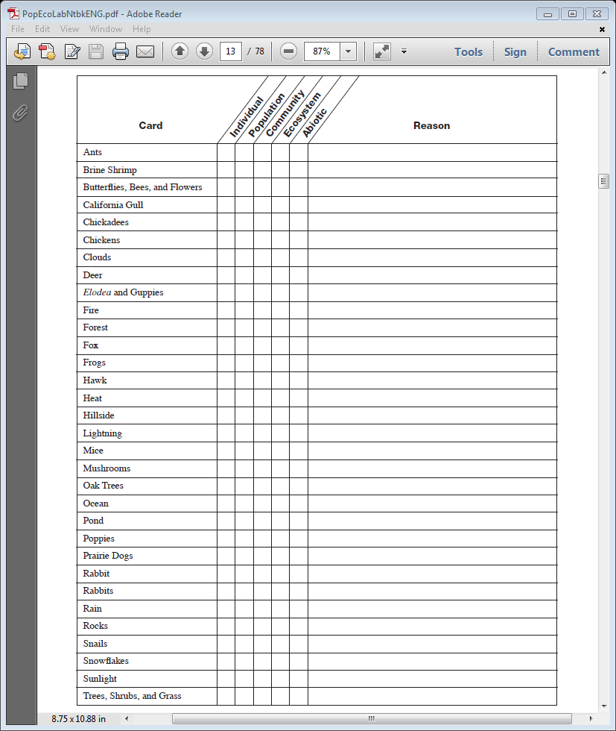
Ecosystem Card-Sort - Criteria that can be used to group organisms and their environmental factors.
Reading: Life in a Community (p. 6-7)
Write a short response to the following question BEFORE reading.
AFTER reading, write a new response that includes evidence from the text that adds to what you previously thought or evidence from the text that has changed your thinking.

How do an ash tree and a robin interact within a typical park area in the southern tier of New York?
Before reading:

After reading:

Word Bank
__________________________________________
__________________________________________
__________________________________________
__________________________________________
__________________________________________
__________________________________________
__________________________________________
__________________________________________
__________________________________________
__________________________________________
__________________________________________
__________________________________________

Content
__________________________________________
__________________________________________
__________________________________________
__________________________________________
__________________________________________
__________________________________________
__________________________________________
__________________________________________
__________________________________________
__________________________________________

Video: Life Among the Wild Chimpanzees
Answer the following questions based upon watching the video.
- What were four important findings from this long-term study of the chimps in Gombe? Why was the work of Jane Goodall so significant?
__________________________________________________________________________________________________________________________________________________________________________________________________________________________________________________________________________________________________________________________________________________________________________________________________________________________________________________________________________________________________________________________________________________________________
- List some of the abiotic and biotic factors in the chimps’ ecosystem and how they affect the chimps’ behaviors.
____________________________________________________________________________________________________________________________________________________________________________________________________________________________________________________________________________________________________________________________________________________________________________________________________________________________________________________________________________________
- Define and provide at least one example of an individual, population, community, and ecosystem in Jane Goodall’s chimpanzee study.

Individual_________________________________________________________________
Population________________________________________________________________
Community_______________________________________________________________
Ecosystem________________________________________________________________
Focus Question 5: How do organisms interact within an ecosystem?
ecosystem 1 |  |  | ecosystem 2
Organism | Rationale |  | Organism | Rationale
List the abiotic features  List the biotic features |  |  | List the abiotic features  List the biotic features
Ecosystem 1

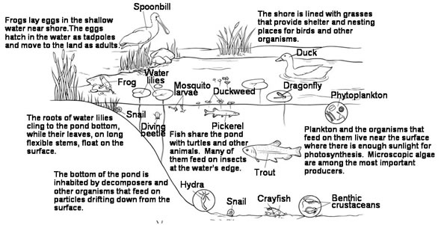

Ecosystem 2
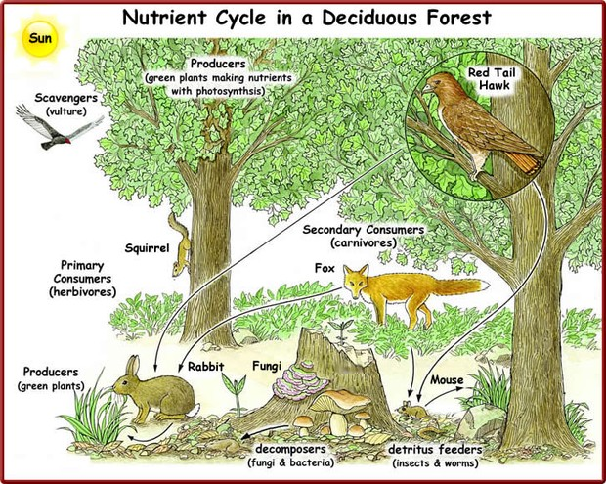
Reflection

Word Bank
__________________________________________
__________________________________________
__________________________________________
__________________________________________
__________________________________________
__________________________________________
__________________________________________
__________________________________________
__________________________________________
__________________________________________
__________________________________________
__________________________________________

Content
__________________________________________
__________________________________________
__________________________________________
__________________________________________
__________________________________________
__________________________________________
__________________________________________
__________________________________________
__________________________________________
__________________________________________

Make a Claim
Based upon your group’s observations of the ecosystems, make a claim about one way organisms interact within an ecosystem.

I claim….

I know this because……

Reading: Biosphere 2: An Experiment in Isolation (p. 8-13)
Read and answer the “Think Questions” for homework.
Focus Question 6: How do humans impact ecosystems?
I used to think…….

But now I know…..

I still wonder……..

BIG QUESTION: What are some important concepts to consider when studying ecosystems and the factors needed to support an organism’s ability to survive and reproduce within their habitat?
I claim…  I claim…  I claim… | I know this because…  I know this because…  I know this because…

