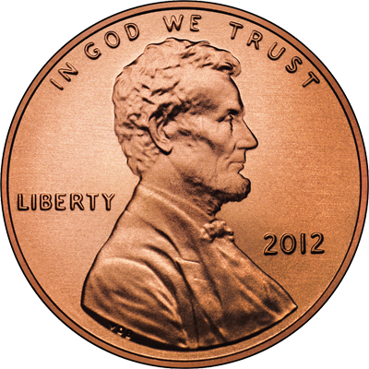
How is the Surface Tension of Water Affected by Soap?

Introduction: Surface tension refers to water's ability to "stick to itself". Surface tension can be measured and observed by dropping water (drop by drop) onto a penny. The number of water drops that can fit on a penny will surprise you.

1. Initial Observation: Observe surface tension by seeing how many drops of water can fit on a penny.

Number of Drops ___________

Question: How does soap affect the water's surface tension?

2. Develop a hypothesis that answers the experimental question. Write your hypothesis below.

3. Test your hypothesis by comparing the number of drops of tap water that can fit on a penny to the number of drops of soapy water that can fit on a penny. Because water drops may vary depending on how well you drop the water, it is best to run many trials and take an average. Record your data in the table below

 | Trial 1 | Trial 2 | Trial 3 | Average
Tap water
Soapy water

4. Analyze the data and draw conclusions. Write a paragraph below (using complete sentences) that explains how soap affects the surface tension of water, using your data to help you answer the question. Suggest a reason for your observations (why did it happen?). Support or reject your hypothesis

Post- Lab Analysis

5. Explain what surface tension is.

6. Why were many trials taken and averaged?

7. In this experiment, what was your control group?

8. Identify the independent variable in the experiment.

9. Identify the dependent variable in the experiment.

10. What other experimental questions can you come up with related to this activity? Describe how you would answer this question using the scientific method. If you have time, you can test this.

