Name ___________________________________Date:_______
Graphing Practice
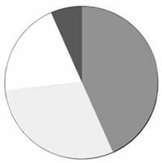
1. A class survey revealed that out of 30 students, 13 listed their favorite lunch item as pizza, 9 chose cheeeseburgers, 6 picked lasagna, and 2 chose tacos.

Label the pie graph

2. Jamie bought a new video game and decided to keep track of his scores.
Try 1 – 150 pts Try 2 – 190 pts
Try 3 – 500 pts Try 4 – 900 pts
Try 5 – 1100 pts Try 6 – 1500 pts
Create a graph of Jamie’s progress. Put the “trys” on the X axis
3. Jamie’s friend, Josie tries out the same game.
Try 1 – 100 pts Try 2 – 500 pts
Try 3 – 900 pts Try 4 – 1100 pts
Try 5 – 1400 pts Try 6 -- 1500 pts

Use the same graph and draw an another line to represent Josie’s scores – Label each line as Jamie or Josie.
4. Based on your graph, who is the better player? Justify your answer.

5. Take a class survey about favorite colors. Find out what your classmates’ favorite colors are using the list below. Create a bar graph that is color coded that compares the class choices
Blue ________________
Red ________________
Green _______________
Yellow _______________
Purple _______________
Pink ________________
Orange _______________

