Objective Lens: 4x  Description:  Estimated Size of Objects: | 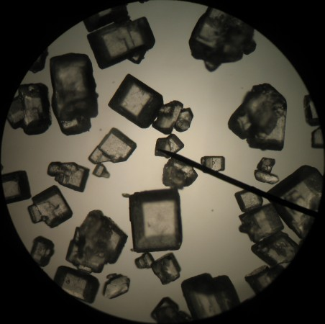
Objective Lens: 4x  Description:  Estimated Size of Object: | 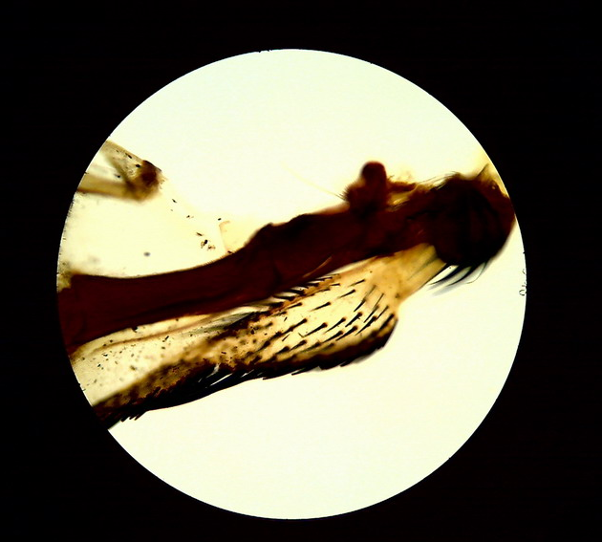
Objective Lens: 10x  Description:  Estimated Size of Objects: | 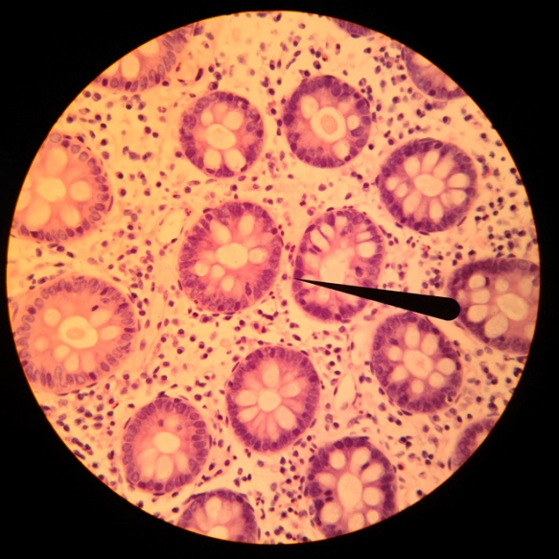
Formative Assessment Probe
Diversity of Life: Investigation 2
Focus Question: How do you use this knowledge of the relationship between magnification and the diameter of the field of view to measure the size of unknown objects?
I claim______________________________________________
____________________________________________________

____________________________________________________

____________________________________________________

____________________________________________________

____________________________________________________

I know this because ________________________________

____________________________________________________

____________________________________________________

____________________________________________________

____________________________________________________

____________________________________________________

