Welcome!
I am excited to have you in class this year.
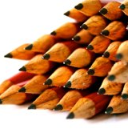
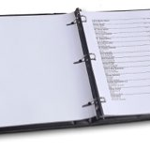
8th grade science is life science. we will be covering topics such as cells, genetics, the human body, and evolution. I have included a list of materials needed for class to the right. Below are three ways you can contact me if you have any questions for concerns.

Pens or Pencils
Have something to write with everyday.

Binder or Folder
This is important for keeping your materials neat and organized.

Colored Pencils, Highlighters
These are optional materials.

Phone
735-3100
1

E-mail
cstone@
elmiracityschools.com
2

remind
Use the attached instructions to sign up
3
Ernie Davis Academy September 7,2016

8th Grade Science
Mrs. Stone
Expectations
My classroom expectations are described below. There will be consequences for not following these expectations that may include time after school, lunch detention, and loss of privileges. Students will have input on our list of rules/consequences. When this is completed it will be posted on my website.
Safety: In a science classroom safety is very important. We will sometimes be working with materials that may be toxic if ingested or could be harmful if they got in your eyes. We may be working with sharp objects or glassware. Following all safety rules for any activity we complete is a must! If the safety rules are not followed students will be completing another assignment.
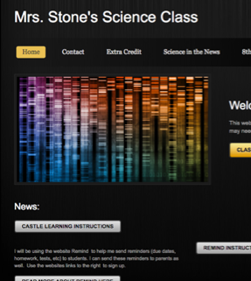
Ownership: It is up to you to get your work done. The teacher can not do the work for you! You must remember to complete homework assignments and take the initiative to study. I do not give you a grade, you earn your grade.

Www.stonescienceeda.weebly.com
Visit my website to find class materials and expectations.
Extra credit opportunities are available here as well.
Acceptance/Respect: All students should treat others (students, teachers, guests to the classroom) the way they would like to be treated. Bullying and intolerance will not be accepted. Consequences would be determined based on the particular situation.
Other: Cell phone use is not allowed in class. They distract students from their job, which is to learn. This goes for music as well. I will have a place In the classroom to store these items when they become a distraction to students.
Food will also not be allowed in class, due to the potential mess. If there is an issue with this (a health issue perhaps) please be sure to contact me.
Tutoring
Grades
I am available after school for tutoring. I have a sign up sheet in my room. Students should sign up at least one day ahead of time, so I can plan ahead. I will have appointments after school throughout the year, so some days may be crossed of and unavailable.
Grades will be determined based on notebook grades/classwork, lab activities (60%), homework assignments (20%), and tests/quizzes (20%). Periodically I will hand out grade reports to students so they can see their progress. I like to send these to parents as well, so please provide an email address if possible.
Students first grade will be the return of the attached form.
Students will be expected to take care of any worked missed during an absence on their own. There will be a bin of work for absent students. It is up to them to take the work and seek any assistance they need to complete it (this may involve staying after school).
If students do not turn in an assignment, they will have three chances to turn it in. 10 points will be taken off if turned in one day late, 20 for two days, and 30 for three days. After that, the work will no longer be accepted. Missed tests and quizzes must be made up within a week and it will need to be done after school.

