STEM Science Notebook
Diversity of Life
Investigation 3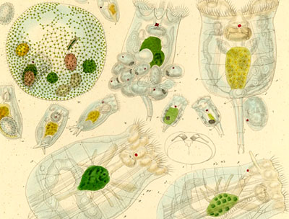

BIG QUESTION: How can a microscope help determine if something is living or nonliving?
Part 1: Discovery
Focus Question: What can we discover about plant life using a microscope?
Characteristics of Life | YES  We have evidence of this in plants. | NO  We have NOT observed evidence of this in plants.
About Elodea

Procedure:

Observations (40x):
Field of View

Estimated Size: _________________________

Explanation:

Observations at 100x:

Field of View

Estimated Size: _________________________

Other Observations?

Field of View

Explanation:

I claim

I know this because

Part 2: Explore
Focus Question:

Procedure Notes:

General Observations:

PARAMECIA

Part 1: Paramecium at 40x
- Set the microscope to 100x.
- Observe one paramecium.
- Draw it as it looks in the field of view at 100x.
- Estimate the length of the paramecium.

Field of view at 40x

- Describe the paramecium’s behavior.

Part 2: Paramecium at 100x
- Find a trapped paramecium and position it in the center of the field of view.
- Increase to 400x and observe the paramecium. Draw the paramecium as it looks in the 400x field of view and describe what you see.

Field of view at 100x

- Reestimate the length of the paramecium.

- Are the paramecia alive? What is your evidence?

FOSS Diversity of Life Course
© The Regents of the University of California
Can be duplicated for classroom or workshop use.
Investigation 3: Microscopic Life
Student Sheet

Compare/Contrast
I claim

I know this because

Explanation:
__________________________________________
__________________________________________
__________________________________________
__________________________________________
__________________________________________
__________________________________________
__________________________________________

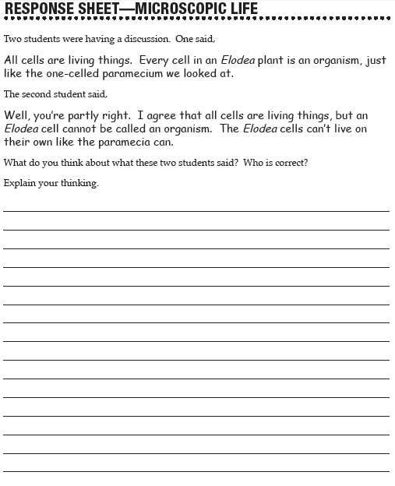

Observations:
Field of View
_________X

Observations:

Field of View
_________X

Observations:
Field of View
_________X

Explanation:
__________________________________________
__________________________________________
__________________________________________
__________________________________________
__________________________________________
__________________________________________
__________________________________________
__________________________________________
__________________________________________
__________________________________________
__________________________________________
__________________________________________
_____________________________________________
Focus Question:

Procedure:

Observations:

Field of View
_________X
I think…..

I wonder….

I claim

I know this because

__________________________________________
__________________________________________
__________________________________________
__________________________________________
__________________________________________
__________________________________________
__________________________________________
__________________________________________
__________________________________________
__________________________________________
__________________________________________

Content
__________________________________________
__________________________________________
__________________________________________
__________________________________________
__________________________________________
__________________________________________
__________________________________________
__________________________________________
__________________________________________
__________________________________________
___________________________________________
__________________________________________
Characteristics of Life

 | BIG QUESTION: How can a microscope help determine if something is living or nonliving?
 | CLAIM | EVIDENCE
 | I claim…  I claim…  I claim… | I know this because…  I know this because…  I know this because…

