STEM Science Notebook
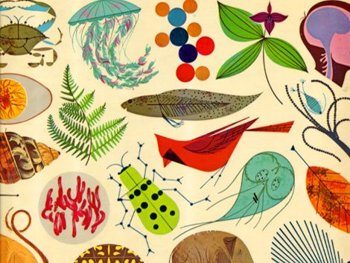

Diversity of Life
Investigation 1

BIG QUESTION: What are the essential characteristics of ALL living things?
Focus Question: How do you know when something is living or nonliving?
Evidence of Life

Observations:

Explanation:

We claim the material is___________________ and

we know this because__________________________

________________________________________________.

ADDITIONAL SPACE for Explanations/Claims/Evidence
________________________________________________________________________________________________________________________________________________________________________________________________________________________________________________________________________________________________________________________________________________________________________________________________________
Living | Nonliving |  | Undecided
Reflection: Have my ideas changed about what it means to be living? If so, how?

I used to think___________________________________
__________________________________________________________________________________________________

but now I think __________________________________
___________________________________________________________________________________________________________________________________________________

I think this because _____________________________
______________________________________________________________________________________________________________________________________________________________________________________________________________________________________________________________________________________________________

I wonder ________________________________________ ____________________________________________________________________________________________________________________________________________________________________________________________________

Revisit Focus Question: How do you know when something is living or nonliving?
CHARACTERISTICS OF LIFE

Evidence of Life
(What do the characteristics of life look like?)
WORD BANK _________________________________________________

_________________________________________________

_________________________________________________

_________________________________________________

_________________________________________________

_________________________________________________

_________________________________________________

_________________________________________________

_________________________________________________

_________________________________________________

_________________________________________________

_________________________________________________

_________________________________________________
Focus Question: Which of these 5 unknown samples are alive?
Predictions:  A:  B:  C:  D:  E: |  | Explanation:  A:  B:  C:  D:  E:
Experimental Plan:

Five Materials Observation Sheet
(include words and drawings where appropriate)
Sample A
Initial Observations | Changes after 10 minutes
Changes after 24 hours. | Changes observed after  ____________
Is it alive? ______________
Evidence of Life: ________________________________
____________________________________________________________
____________________________________________________________
Five Materials Observation Sheet
(include words and drawings where appropriate)
Sample B
Initial Observations | Changes after 10 minutes
Changes after 24 hours. | Changes observed after  ____________
Is it alive? ______________
Evidence of Life: ________________________________
____________________________________________________________
____________________________________________________________
Five Materials Observation Sheet
(include words and drawings where appropriate)
Sample C
Initial Observations | Changes after 10 minutes
Changes after 24 hours. | Changes observed after  ____________
Is it alive? ______________
Evidence of Life: ________________________________
____________________________________________________________
____________________________________________________________
Five Materials Observation Sheet
(include words and drawings where appropriate)
Sample D
Initial Observations | Changes after 10 minutes
Changes after 24 hours. | Changes observed after  ____________
Is it alive? ______________
Evidence of Life: ________________________________
____________________________________________________________
____________________________________________________________
Five Materials Observation Sheet
(include words and drawings where appropriate)
Sample E
Initial Observations | Changes after 10 minutes
Changes after 24 hours. | Changes observed after  ____________
Is it alive? ______________
Evidence of Life: ________________________________
____________________________________________________________
____________________________________________________________

Five Materials Summary
I claim that Sample A is ______________________________
I think this because __________________________________
_____________________________________________________
_____________________________________________________
_____________________________________________________

I claim that Sample B is ______________________________
I think this because __________________________________
_____________________________________________________
_____________________________________________________
_____________________________________________________

I claim that Sample C is ______________________________
I think this because __________________________________
_____________________________________________________
_____________________________________________________
_____________________________________________________

I claim that Sample D is ______________________________
I think this because __________________________________
_____________________________________________________
_____________________________________________________
_____________________________________________________

I claim that Sample E is ______________________________
I think this because __________________________________
_____________________________________________________
_____________________________________________________
_____________________________________________________

Reflection: Has anything changed in my thinking about what it means to be alive?
I wonder ____________________________________________
_____________________________________________________
_____________________________________________________
______________________________________________________

Five Materials Summary Page
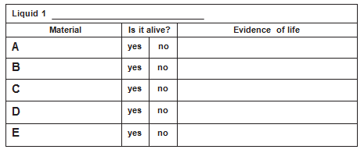
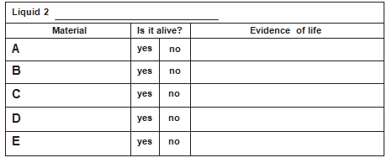
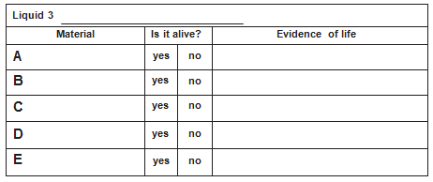

Reading: “Life on Earth” (p. 21-23)
Claim Before |  | Statement |  | Claim After
Agree | Disagree |  |  | Agree | Disagree
1) A plant is an example of an organism.
Evidence:

2) A rock is an example of something that is dead.
Evidence:

3) Something non-living is when it is no longer alive.
Evidence:

4) All organisms engage in gas exchange.
Evidence:

5) One function performed by all living organisms is a response to their environment.
Evidence:

6) Every individual organism will reproduce to keep a species going.
Evidence:

7) An object qualifies as living if it meets ALL four basic needs and ALL three functions of all living organisms:
Evidence:

WORD BANK
______________________  ______________________  ______________________  ______________________  ______________________  ______________________  ______________________  ______________________  ______________________  ______________________  ______________________  ______________________ |  |  | ______________________  ______________________  ______________________  ______________________  ______________________  ______________________  ______________________  ______________________  ______________________  ______________________  ______________________  ______________________
CONTENT
________________________________________________
________________________________________________
________________________________________________
________________________________________________
________________________________________________
________________________________________________
________________________________________________
________________________________________________
________________________________________________
________________________________________________
________________________________________________
________________________________________________
________________________________________________
________________________________________________
________________________________________________
________________________________________________
________________________________________________
________________________________________________
________________________________________________
________________________________________________
________________________________________________
________________________________________________
________________________________________________
________________________________________________

BIG QUESTION: What are the essential characteristics of ALL living things?
CLAIM |  |  | EVIDENCE
I claim  I claim  I claim |  |  | I know this because  I know this because  I know this because

